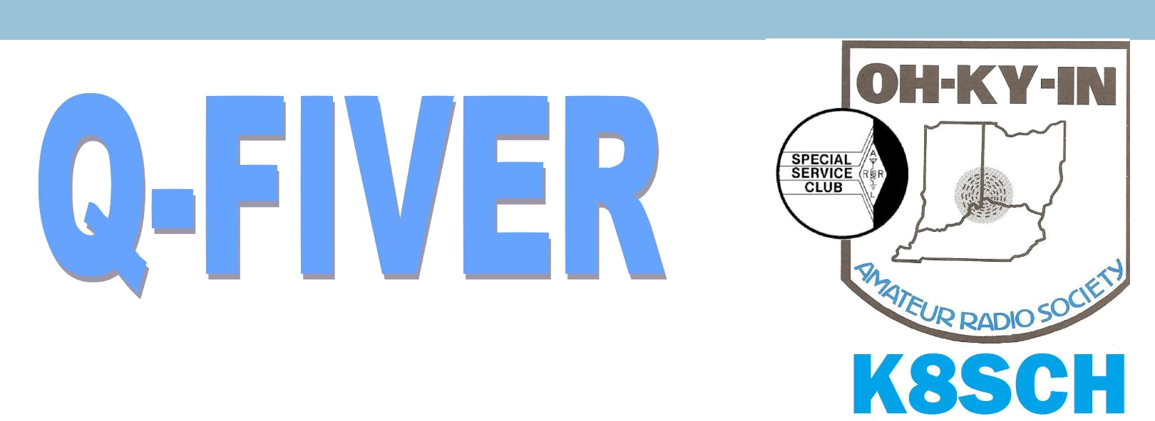  OH-KY-IN Amateur Radio Society | December 2015
 | Volume 55, Issue 12

The Official Newsletter of the OH-KY-IN Amateur Radio Society

FROM THE PRESIDENT

Thank you to Dick, WB4SUV for a super presentation at the November meeting. Dick’s skills are many and varied and were well used in the effort to snag a jammer that harried many repeaters for a long time. He designed and built new equipment that was outside the box of previous thinking, and that was an important part of a successful conclusion of which Dick was an integral part.

Several things about the club meeting on Tuesday December 1. First, it will be our annual Holiday Party. Pizza will be provided by the club, but we would like you to contribute to the cause. Needed are soft drinks; cakes, cookies and pies; and whatever else you would like to bring (no alcoholic beverages, please). I will ask the Board to also pay for plates, cups and napkins.

Second, we will have the election of officers for the coming year and one Director for a three year term. Nominations were closed at the November meeting pursuant to our By Laws. The election is in December and the installation at our first meeting in 2016, Tuesday January 5, 2016. Nominations: Michael Sien, KD8SOH for President [currently our Vice President], Ryan Williamson, W1RYN for Vice President [currently a Director], Ted Morris, NC8V for Secretary [our current Sec-retary] and Brian DeYoung, K4BRI for Treasurer [our current Treasurer]. There is one Director to be elected to a three year term. There are three nominees for this position, listed here alphabetical-ly: Gary Coffee, KB8MYC [our immediate Past President], Mike Niehaus, KD8ZLB [a member of the Nominating Committee], and Bruce Vaneslow, N8BV [a current Director]. Ballots will be ready. Third, there will be a drawing for door prizes. All door prize tickets bought during 2015 will be used for this drawing. There is time to purchase additional tickets before the drawing, which I plan to hold during the party. Door prizes of which I am aware: one brand new Yaesu FT1900R, a two me-ter mobile radio; one new Yaesu FT60R, a dual band [VHF/UHF] handheld radio, and one gently used Yaesu FT252 two meter handheld radio in like new condition. Additional door prizes can be donated, but they must be either new or almost new condition; all should be or related to ham radio equipment or books. The usual split the pot drawing will be held first so that all those tickets can be added to the door prize drawings.

Minimal other business will be conducted.

This has been a great year for our club! Join us to celebrate and support each other in our ham ra-dio endeavors. Guests are welcome.

Fred Schneider, K9OHE, President
2015 Board of Directors


President
Fred Schneider K9OHE ............ | (513) | 729-0945 ...... | fschneider@fuse.net
Vice President
Michael Sien KD8SOH ............ | (513) | 312-0691 ...... | Michael.sien@zoomtown.com
Secretary
Ted Morris NC8V ..................... | (513) | 731-3451 ...... | nc8v@hotmail.com
Treasurer
Brian DeYoung K4BRI ........... | (859) | 635-3095 ..... k4bri@arrl.net
Directors
Bryan Hoffman KC8EGV ......... | (513) | 851-0525 ..... hoffgroup@gmail.com
Bruce Vanselow N8BV ........... | (513) | 251-1555 ..... n8bv@juno.com
Ryan Williamson W1RYN ........ | ................................ |  | w1ryn@w1ryn.me
Trustee/Licensee
Bruce Vanselow N8BV ........... | (513) | 251-1555 ..... n8bv@juno.com
Past President
Gary Coffey .............................. | (513) | 382-3879 ...... | kb8myc@fuse.net

OH-KY-IN Repeaters

146.670 (-) Clifton

146.625 (-) Edgewood, KY

146.925 (-) Colerain Twp

443.7625 (+5) Clifton

A CTCSS (PL) tone of 123.0 Hz is required for access to all OH-KY-IN repeaters. All repeaters also trans-mit a CTCSS (PL) tone of 123.0 Hz

APRS on 144.390 mHz

K8SCH-10 Edgewood WIDEn

K8SCH-9 Clifton WIDEn

Packet on 145.010 mHz

K8SCH-7 Digipeater

For membership information, please contact Na-than Ciufo KA3MTT, 6323 Cinnamon Ridge Dr, Burlington KY 41005, (859) 586-2435 or Email membership@ohkyin.org. Renewals of Club Memberships are due by the end of March. Permission is hereby granted to any amateur radio group to quote or reprint from this publi-cation, if proper source credit is given, unless permission is otherwise reserved.

THE Q-FIVER is now mailed & e-mailed, it's hoped, a week before the club meeting.

Normally copy deadline is the weekend before that. Please send your submissions for THE Q-FIVER (including notice of upgrades & callsign changes) to Brian K4BRI

These may be: snail-mailed to or dropped off at 6901 Backus Drive, Alexandria KY 41001 or tele-phoned to (859) 635-3095 any time

Oh-Ky-In Life Members

John Phelps N8JTP

Kenneth E Wolf N8WYC

John W Hughes AI4DA

Karl W Kaucher KJ4KWR

Howard Hunt NG8P

2

2015 Committee Chairs and Appointments

Newcomers/Elmers Net ................ | Robert Gulley AK3Q | Q-Fiver Editor ............................ | Brian DeYoung, K4BRI
Technical Committee ................ | Brian DeYoung, K4BRI | Field Day .......................................... | Eric Neiheisel N8YC
ARPSC Representative .................... | Jerry Shipp W1SCR | Historian .................................. | Dale Vanselow KC8HQS
Volunteer Examiners .................. | Brian DeYoung K4BRI | Special Publications ................. | Jo Haltermon KD4PYS
QCEN Representative ...................... | Pat Maley KD8PAT | Fox Hunters .................................. | Dick Arnett WB4SUV
Membership ............................... | Nathan Ciufo KA3MTT | Equipment Mgr ........................... | Brian Fulmer KC8FJN
Fundraising ................................ | Bruce Vanselow N8BV | WebGeezer ................................... | Russ Hines WB8ZCC
Education ....................................... | Robert Gulley AK3Q | Silent Key ................................... | Bruce Vanselow N8BV
Repeater Control Ops Mgr ........ | Bruce Vanselow N8BV | Tech Talk Net Mgr ..................... | Bruce Vanselow N8BV
PIO ........................................................ | Ted Morris NC8V | K8SCH QSL Mgr ......................... | Gerry Weimer KD8ASL
Librarian ........................................... | Howard X KD8WOY | TV/RFI .......................................... | Dick Arnett WB4SUV

The December meeting will not only be elections, but will have free pizza and soft drinks, and some very nice door prizes

December Calendar

Tue Dec 1 | 7:30 PM | Club Meeting at St Bernard Recreation Hall, 120 Washington Avenue.
 |  | Program: Elections and Pizza Party
Wed Dec 2 | 9:00 PM | Tech Talk, NCS Robert AK3Q
Sun Dec 6 | 7:00 PM | Newcomers/Elmers Net, 146.67 146.67, Topic: Christmas Gifts to Make the Season Bright
 |  | —NCS Robert AK3Q
Wed Dec 9 | 9:00 PM | Tech Talk, NCS Brian K4BRI
Sat Dec 12 | 10:00 AM | Mobile Foxhunt, starting at Mt. Storm park in Clifton—talk in on 146.670
 | 1:00 PM | Brunch Bunch at Blue Ash Chili - 11711 Princeton Pike
Sun Dec 13 | 7:00 PM | Newcomers/Elmers Net, 146.67, Topic: Building an Indoor Antenna —NCS Robert AK3Q
Wed Dec 16 | 9:00 PM | Tech Talk, NCS Dale KC8HQS
Sun Dec 20 | 7:00 PM | Newcomers/Elmers Net, 146.67, Topic: Experimenting with "Bad" Antennas —NCS Robert AK3Q
Tue Dec 22 | 7:00 PM | Board of Directors meeting
Wed Dec 23 | 9:00 PM | Tech Talk, NCS Brian KC8FJN
Sun Dec 27 | 7:00 PM | Newcomers/Elmers Net, 146.67, Topic: New Year Radio Plans —NCS Robert AK3Q
Wed Dec 30 | 9:00 PM | Tech Talk, NCS


3

Ham Operation from NA-100 de KA3MTT

During the month of June, 2015, my family and I went to Hilton Head Island, SC. To most, this island getaway is simply a vacation spot and somewhere to lounge, relax, enjoy the ocean, and get away from the hussle and bustle. To me, however...this was an opportunity to operate from an IOTA designated
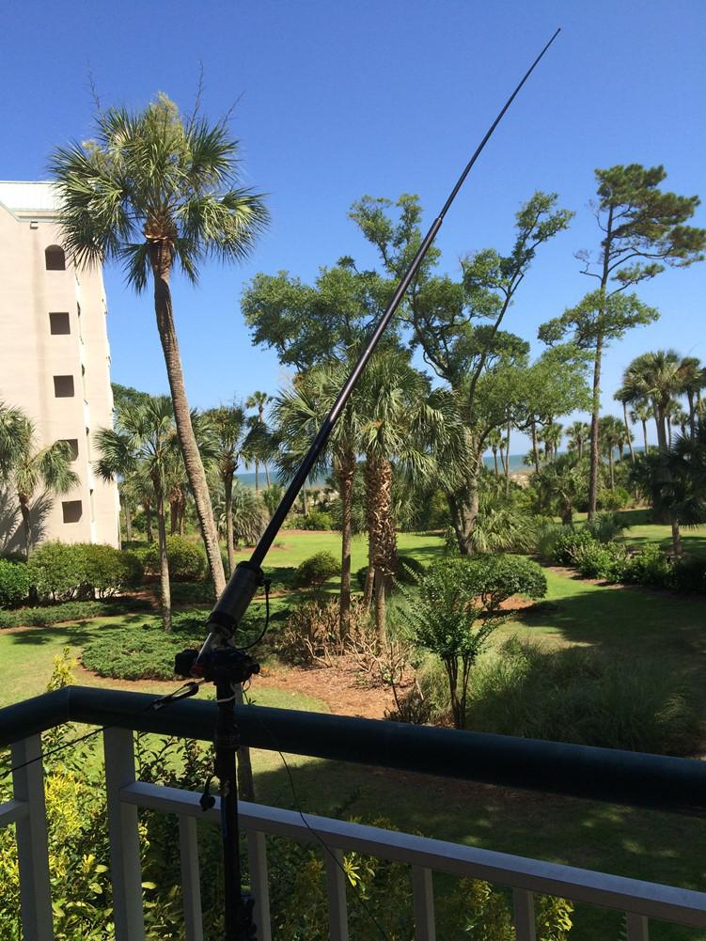
NA-110!

IOTA stands for Islands on the Air, and the program manager is Roger, G3KMA. There are many “island chasers”, and they try to work as many islands as possi-ble.

Each island has it’s own designation number, which is preceded by the continent it’s part of. The IOTA system has been in operation for 51 years now.

The planning for this venture began before the Dayton Hamvention, as I decided it was time to buy a Buddi-pole system. For those not familiar with a Buddipole, I will send you to their website: www.buddipole.com
A Buddipole is one of the most versatile antenna SYS-

TEMS I have ever worked with. It’s an HF/VHF portable dipole system which has more configurations and possibilities than one can imagine.

My operation was going to be simple: a Yaesu FT-857, a switching power supply, an-tenna tuner, and the antenna itself. I promised myself I wasn’t going to operate more than 20 watts, just to see how well I could do. The results were astounding, to say the least.

Our days typically began at the beach, then back to the condo for lunch, followed by an early afternoon at the pool.

Then came the issue of trying to talk the kids into leaving the pool. It usually started with, “Hey guys...anyone want some Cheetos????” That worked once.

Then I would hear, “Daddy just wants to go up to the condo to get on that radio.” While my son, KA3MTU, is obviously a ham, he was way more interested in the pool and palm trees than getting on the radio. Who can blame a 12 year-old?

However...once I was lucky enough to get everyone upstairs, it was an afternoon of ham radio in paradise, along with a few gin & tonics.

(Continued on page 5)

4

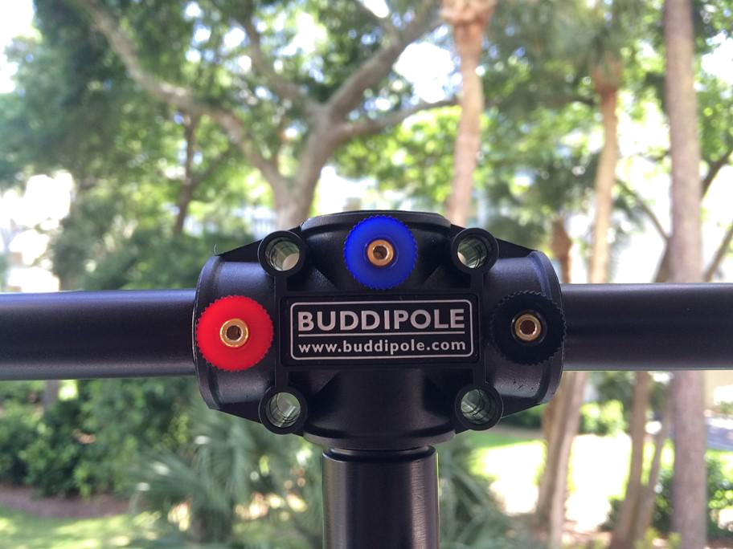
(Continued from page 4)

The center of the Buddipole dipole system.

Notice the 3 banana plugs. These are used in many configurations of the antenna.

I started using the Buddipole in a dipole configu-ration, but soon realized that I needed to change to an angled vertical because of how close the balcony roof was to the antenna. The concept of the Buddipole is NOT to use an antenna tuner if

you don’t have to. When you are able to get a good SWR match without a tuner, you have a very efficient system. While it’s easiest to tune the antenna with an SWR me-ter, you can also roughly tune it to maximum noise level, and then fine tune from there, which is the approach I took.

The system has everything from dipole arms, to coils, a balun, tripod, telescopic whips, etc. It truly is a marvel of engineering. I used a coil at the bottom of the vertical, fol-lowed by a dipole arm, and a telescopic whip. There is even a wire assembly for creating a counterpoise that you can tune simply by vary-ing the length. This proved to be the ticket for this operation.
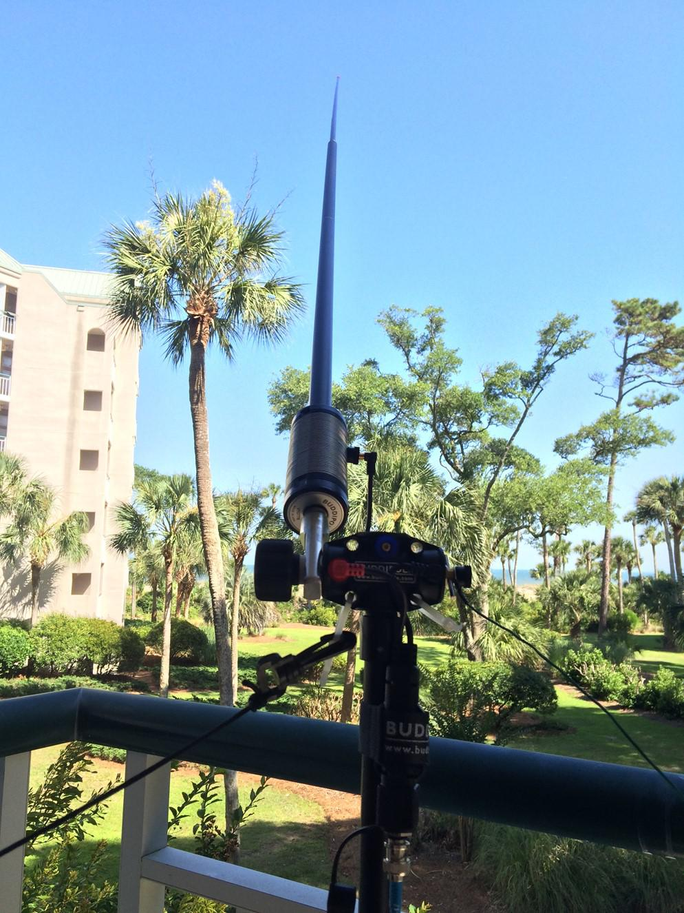

In the picture on the left, you can see the coil with the wire tap that chooses the length of the coil, the dipole arm, then the tele-scopic whip.

The counterpoise wire can be seen extending out of the right side of what’s called the “Versa-Tee”.

While the wind picked up a couple of days, I used a guy rope shown coming from the left side of the Versa-Tee.

All of my contacts were made on 20 meters, with the vast majority using CW. Yes, I’m one of those CW nuts.

However, my first QSO was using SSB and I contacted Allan, WP4A, in Gainesville, TX. The rest were all using CW, and I contact-ed states such as Rhode Island, Idaho, and even a guy named Brian, K4BRI in Ken-tucky!!!

To sweeten the pot a bit, there was an evening where Nicole and the kids were watching a movie, and I thought it was a perfect opportunity to try searching for some DX across the ocean. I’m glad I did...I was able to contact Ukraine, and Russia

- on 20 watts from this “compromised antenna.” | 5
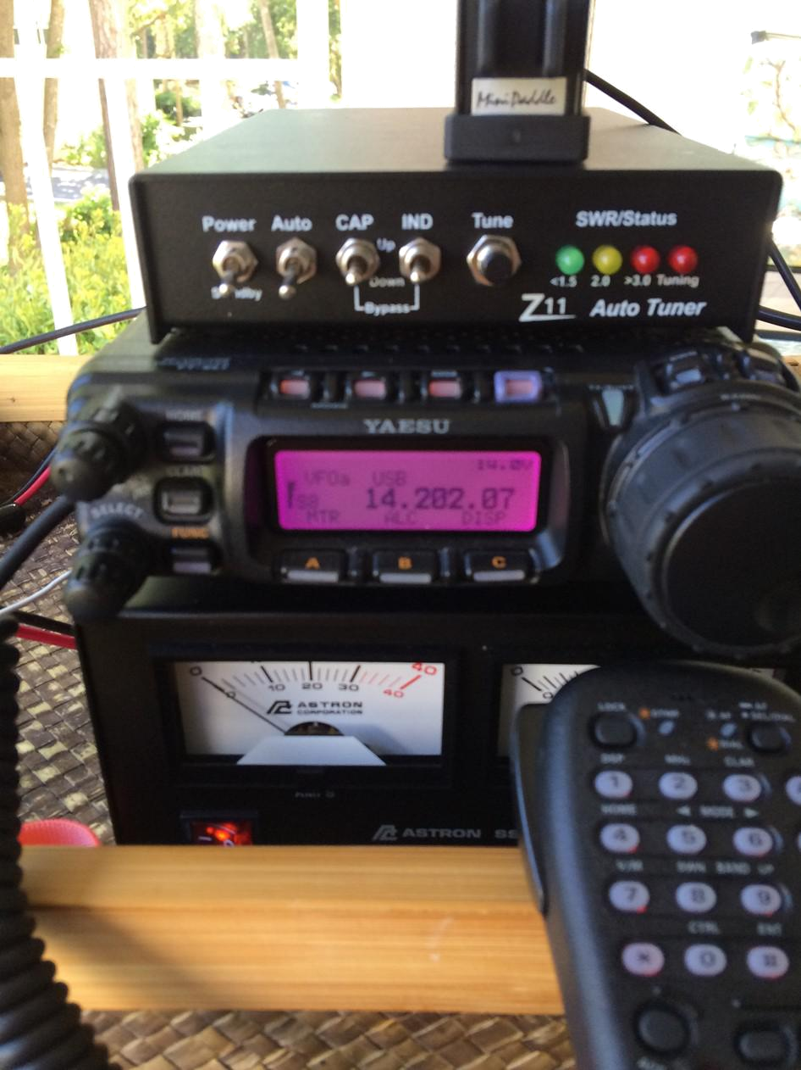
The image to the right shows my station setup:
Astron SS-30 Switching Power Supply
Yaesu FT-857
LDG Z11 Antenna Tuner (which was never used)

Palm Radio Mini Paddle for CW

The entire setup fit on a serving tray, and I kept it that way the en-tire week. When I was ready to operate, I took it out to the balco-ny, and when I was done, it went right back inside.

KA3MTU with

The boat captain and shark he caught … just before the sea-sickness began!
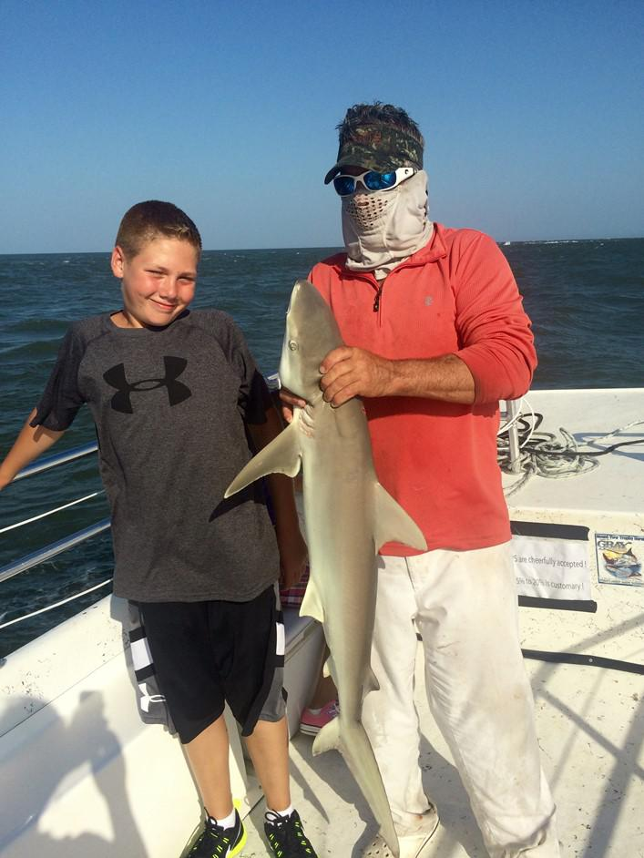

One of 13 sharks we caught on a shark-fishing trip that week!
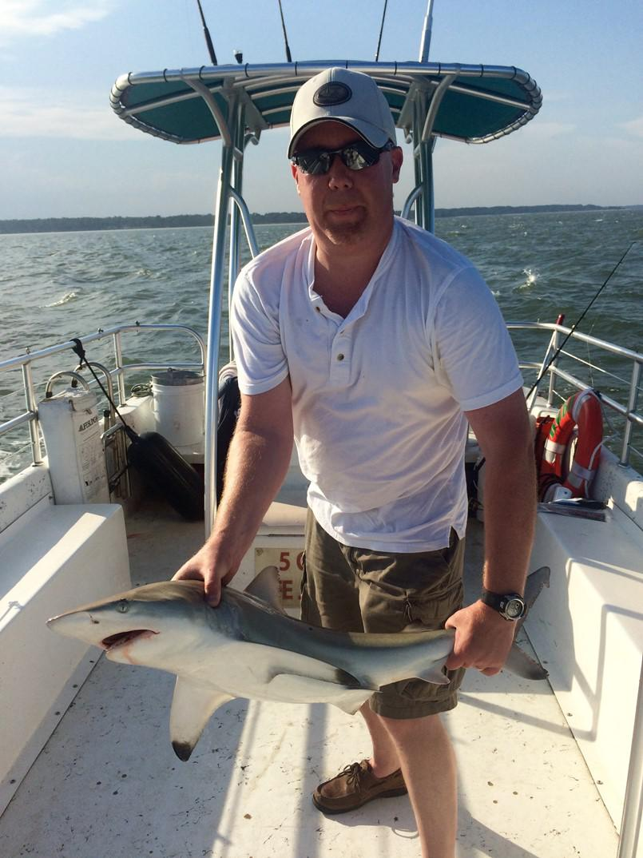

There are 2 morals from this story and trip: do NOT underestimate an antenna that some may say is “compromised”, AND… always take motion sickness medication be-fore going deep sea fishing! Best of 73, Nathan KA3MTT
Foxhunting and ARDF

The October mobile hunt had the two regular hunters, Dick WB4SUV, and Marji KJ4ZKC & myself, as well as two new teams—Ron WD8VOR, and Howard KD8WOY, Marty KE8CEI and Mike KC8IVR. It was great having more teams in the foxhunt, but I have to be careful not to train them too well
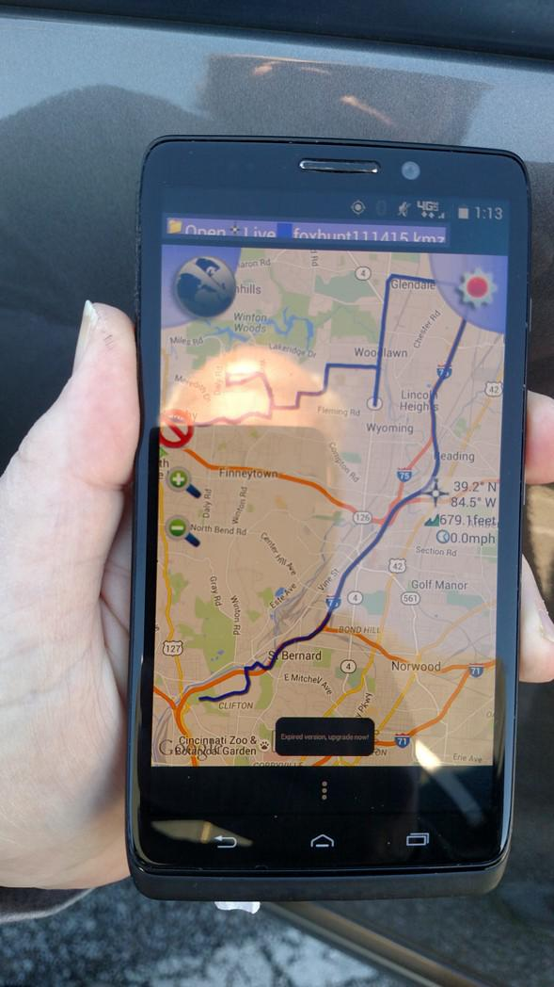
hihi.

Good signal at the start—I had about 35 degrees. Shortly after leaving the starting point, I started having signal dropouts and ambiguous readings. We chased wrong signals for a while until I finally said I need to stop and look at stuff. Sure enough, my coax connector to the antenna had worked loose and wasn't even making contact. After that, we went pretty much right to him.

Ron beat Dick—way to go! We ended up coming in a late third.

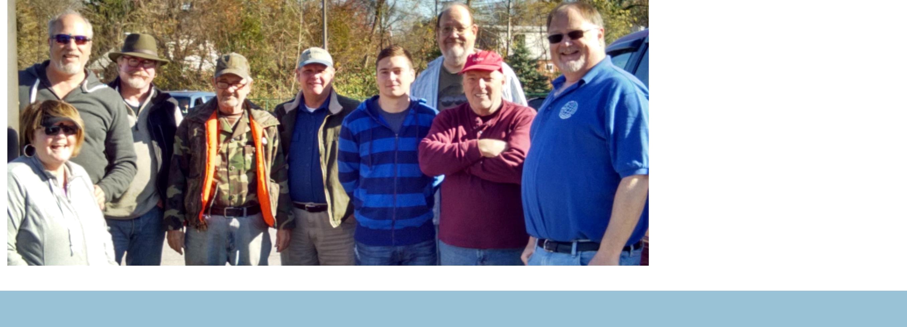

Brunch Bunch

The next Brunch Bunch will be held Saturday, December 12th at 1pm. The location for December is Blue Ash Chili, Tri-County loca-tion. The Tri-County location of Blue Ash Chili is located at 11711 Princeton Pike (Ohio 747) near the corner of Princeton Pike and West Kemper Road. Blue Ash Chili is between Harbor Freight and Hobby Lobby.

The Brunch Bunch visited the Blue Ash location some time ago and found that its layout did not work well with our large group. The Tri-County location has assured me that they can pull tables together and attach them to a booth at the rear of the restaurant to accommodate our group with no problem. Our reservation is in the name of "Radio Club".

For a look at the menu as well as a map and directions to the restaurant, please go to:

www.blueashchili.com

Remember that the Brunch Bunch always meets the second Saturday of every month at 1pm at a location to be announced each month. If you can't join us this

month, maybe you'll be available to join us in the months ahead.

I'm always looking for suggestions on what restaurant you think might be a good place for the Brunch Bunch to visit soon.

73, ……..Bruce, N8BV

7

The Elmer’s Corner


Elmers Corner: Short Wave Listening (SWL)
By Robert Gulley AK3Q

One of the things which makes the radio hobby so pleasurable for me is how easy it is to find interesting things to listen to on whatever radio happens to be handy. From the cheap-

est AM-only radio to the fanciest software defined radio and beyond, every listening opportunity holds the potential for something enjoyable with even the smallest effort.

As an Amateur radio operator there is no question I love being able to talk to people thousands of miles away on the ham bands, but the love of all things radio began with AM DX and then grew exponentially as I listened to shortwave radio as a young boy. To this day shortwave radio holds a special place in my life—both as a source of good memories and as a “window on the world” not available anywhere else.

For those outside the U.S. they know the value of shortwave radio firsthand—often it is the only source of unfiltered world news available. For those in the United States I fear far fewer people are being ex-posed to the wonder of SW radio as the Internet and cell phones top the list of favorite technologies with the younger generation. This is not only a great loss for younger generations in general, but a loss for our culture as a whole.

Broadcasts from the BBC, Deutsche Welle, and the Netherlands, just to name a few, were fascinating to me as a child, and they remain so. Wide-ranging perspectives on current events and exposure to diverse music and cultural influences make SW listening invaluable.

Rumor has it that Shortwave radio is dying-- don't you believe it! Forgive my adaptation of that old quote: "Reports of Shortwave's demise have been greatly exaggerated!" Shortwave is alive and well (just like Amateur Radio!). Just the other night I was listening to Radio Cairo on a portable SW radio, using only my built-in telescopic whip. I have also heard Romania, Germany, Taiwan, Japan, Russia, China, It-aly, and Malaysia, just to name a few. Tune outside the Amateur bands and you will find many, many stations, with numerous ones broadcasting in English. I have to admit though, I listen as much or more to non-English stations as English ones—I find I really enjoy listening to cultural music even when I can't understand the words. The range of music and entertainment on shortwave broadcasts is truly amazing!

Fall and winter are excellent times to acquaint, or re- acquaint yourself with the world of shortwave. Shortwave listening does not have to be complicated of course, but there is plenty of room for experi-mentation with radios and antennas.

Shortwave is good practice for developing listening skills for Amateur radio

- propagation conditions, listening skills, and learning to hear folks speak in other languages all im-proves your amateur radio experience

- there are always digital modes to listen in on, as well as beacons
to hear, utility stations, and multiple bands with varying seasonal propagation characteristics

- this means you do not have to wait until you have HF privileges to get some real benefit out of the shortwave radio bands

- and if your radio has SSB options, then you can listen in on hams around the world.

- BTW, this might just be a good reason to get an amateur radio rig for HF even if you don’t have your General license yet

– they also make great shortwave radio rigs!!

Antennas For SWL

One issue of which to be aware involves the sensitivity of portable shortwave receivers. It is very easy to overload them because of their design. They are particularly sensitive to RF signals, and this can be a great advantage when trying to pull out weak or distant signals. The down side to this is the increased sensitivity can cause strong signals to blow out nearby weaker signals, or worse yet, allow strong signals to be heard across multiple bands.

8

(Continued on page 9)

(Continued from page 8)

There is such a thing as too much antenna for your radio, and this can only be discovered by trial and error. Listen to a portable with just the built in antenna for a few moments on several different frequen-cies and note the quality of the signal. Then compare this to the quality of the signals received with a long wire or dipole antenna. You may actually find the need to shorten the antenna.

Getting Started

The most basic antenna is the included whip antenna on the receiver (I am going to assume the use of a portable for beginners here—if you are starting out with a tabletop you probably already have an antenna in mind). Try working stations starting at about the 40 meter band and see what comes in. While built-in antennas are much maligned, a 2-3 foot antenna will pull in more than might be expected. The fact is, with a decent portable there are likely more stations available than there is time to listen to them—and the telescopic whip has one really big advantage: it keeps a portable receiver portable!

Taking The Next Step

Of course there will be days when you want to root out some weak signals and/or more distant stations, and this will require a better antenna. One inexpensive option is to put up a random length wire out the window to a nearby (non-metallic) support. If there are trees around the house there is likely to be one which will make a good mast for a random or long wire. If possible, it is best to tie the wire off with an insulator and then use some rope to run between the insulator and the tree.

When using a wire antenna of any sort always remember to keep it away from other metal structures. If the window frame is metal, rig up something to insulate the wire from the frame to avoid shorting the antenna. And of course, always take the proper precautions to protect yourself, the radio, and your house from lightning damage.

Disconnect any and all antennas from your radios if you suspect the possibility of storms anywhere near your area, and get lightning protection for your antennas as well. Nothing is perfect, especially if the an-tenna takes a direct hit, but good safety precautions will pay dividends more often than not! Talk with knowledgeable people about what is available for your particular setup, and get in the habit of practicing safety in the radio hobby.

The end of the wire which connects to the radio can be attached several ways depending on the radio. Some radios come with an external antenna jack which likely uses a 1/8˝ mini connector; if this is the case just connect the wire to the center post of the connector and plug it in. If the radio doesn't have a wire jack or terminal, wrap one end of the wire around the antenna and it will still be good to go. Some radios come with a wire antenna wrapped on a reel somewhat like fishing line, and these are often able to be connected directly to the built-in antenna with a snap-on clip.

Give it a Try

Shortwave radio is fun, easy to do, and can be as casual as you like. A simple portable radio will pull in a lot, and if you really get into going for the weak stations, a good outdoor antenna and an amateur radio rig will work wonders! When the amateur bands are quiet, there is a whole shortwave radio world just waiting to be discovered, and you will become a better amateur operator for the experience! 73, Robert

9

September Minutes Corrections

CORRECTIONS TO MINUTES OF SEPTEMBER 1, 2015 REGULAR MEETING: In re: State Parks on the Air, Bobby Revis' call sign was misidentified--he is KD8TPU; also Michael Sien's (KD8SOH) last name was misspelled. In re: the website, President Fred Schneider K9OHE thanked also WB8ZCC for his cooperation in transferring the website to Ryan Williamson W1RYN.

Amazon Smile

Do you make purchases from amazon.com? If so you can help OH-KY-IN earn money from your purchases.

OH-KY-IN is an eligible organization to receive .05% from most of the purchases you make from Amazon. How does this work? Go to www.smile.amazon.com and all of the information about how this works is there. On that page you can make your selection of what eligible organization you want the rewards from your purchases to be sent to. If you type OH-KY-IN Amateur Radio Society into the box it will locate our club. Make that your selection and then you are done.

Once you have that set you can then start making purchases and our club will reap the benefits. The only thing that is different is that when you make purchases from Amazon, you'll need to go to www.smile.amazon.com rather than just amazon.com. Nothing else will be different than what it was pre-viously with your purchases and/or your account with amazon. This is explained on the webpage where you made your selection. And you can change your charitable organization selection any time you if you should decide not to have rewards from your purchases go to OH-KY-IN any longer (we hope that doesn't happen!).

Particularly since the Christmas season is almost here, you can imagine how this "free money" can really add up and it does not cost you or the club anything.

So once you've selected OH-KY-IN Amateur Radio Society as your charitable organization of choice, when you make purchases from Amazon you just need to remember to go to www.smile.amazon.com and make your purchases from there. It's that easy!

73, ...... Bruce N8BV

10

December DX Spots de KA3MTT

Sun | Mon | Tue | Wed | Thu | Fri | Sat
T2TT - Tuvalu thru | FR - Reunion thru | 1 | 2 | 3 | 4 | 5
12-3 | 12-3 |  |  | 3D2RJ - Fiji thru |  | 8P9EZ - Barbados
 |  |  |  | 12-10 |  | thru 12-12
 |  |  |  | -------------
 |  |  |  | KH2 - Guam thru
 |  |  |  | 12-9
 |  |  |  | -------------
 |  |  |  | E51 thru 12-12
6 | 7 | 8 | 9 | 10 | 11 | 12
3D2AG/p - Rotuma |  |  | EA8 - Canary Is | KH0 - Mariana Is |  | FJ - St
thru 1-6 |  |  | thru 1-10 | thru 12-13 |  | Barthelemy thru
 |  |  |  |  |  | 12-17
13 | 14 | 15 | 16 | 17 | 18 | 19
 |  |  | VK2IAY/9 - Lord
 |  |  | Howe Is thru 12-23
20 | 21 | 22 | 23 | 24 | 25 | 26
 |  | T88RY - Palau |  |  |  | 6W - Senegal thru
 |  | Thru 12-29 |  |  |  | 1-12
27 | 28 | 29 | 30 | 31
YJ4AO - Vanuatu
thru 1-13





11



OH-KY-IN Amateur Radio Society

Regular monthly meetings are held the first Tuesday of each month at 7:30PM local time at the St Bernard Recreation Hall, 120 Washington Avenue (corner Washington & Tower Aves) in St Bernard, just east of Vine St. Please come in the doors at street level, facing the high school. Visitors are ALWAYS welcome!

.
The next meeting of the Oh-Ky-In Amateur Radio Society will be Tuesday, December 1st at 7:30 PM

Pizza Party!!!!!

It’s that time of year again—time to gather together, elect club officers, give away some great door prizes, and of course—free pizza!

Come join us on December 1st at 7:30 for our annual holiday party. Piz-za will be provided, but we sure could use some sides and desserts— bring what you like and let everyone else share it.

Door Prizes:

Yaesu FT1900R, a two meter mobile radio; Yaesu FT60R, a dual band [VHF/UHF] handheld radio, Yaesu FT252 two meter handheld radio—and maybe more!

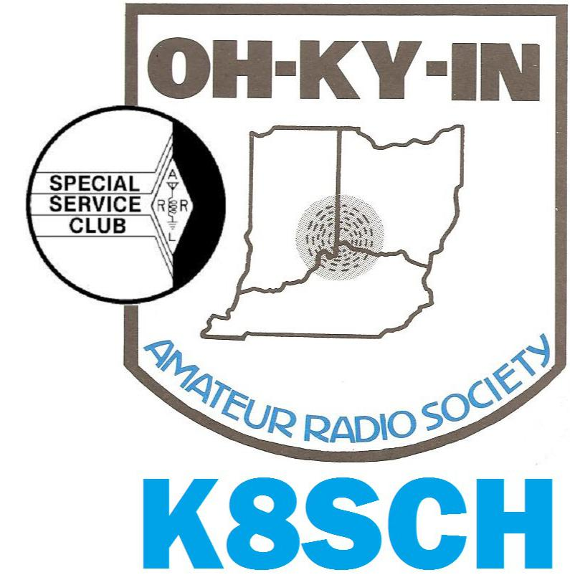
OH-KY-IN Amateur RadioPLEASESocietyPLACESTAMPQ-FIVER EditorHEREBrian DeYoung, K4BRI6901 Backus DriveAlexandria, KY 41001Phone: (859) 635-3095Web: www.ohkyin.orgE-mail: k4bri@arrl.net

