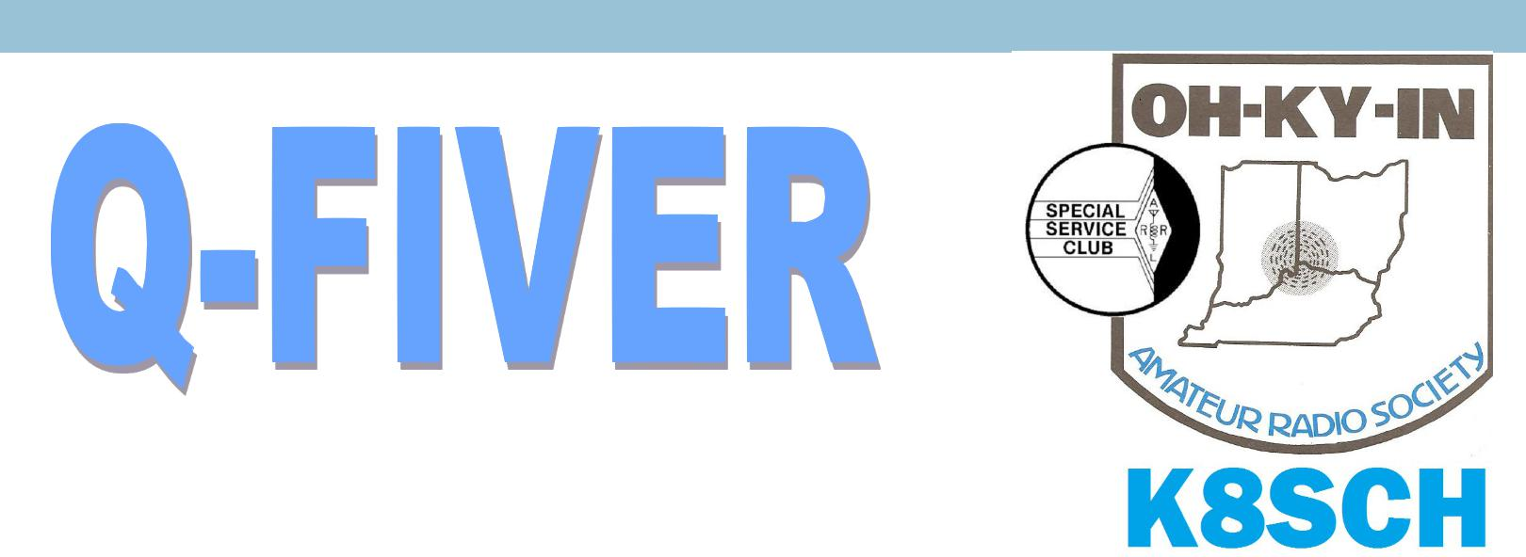OH-KY-IN Amateur Radio Society | November, 2015
 | Volume 55, Issue 11

The Official Newsletter of the OH-KY-IN Amateur Radio Society

From the V/P’s desk….October time to think about Winter Projects!

As I sit down to write this article the month of October is almost in the log books! I am sitting here thinking what an awesome summer I have had! All of the outside activities such as Field Day, Ohio QSP Party, and Ohio Parks On The Air and helping Brian DeYoung and Dick Arnett take down towers! What am I going to do this winter? What am I going to do that will help me keep the intensity up for the hobby I love?

That inspiration came at our October Club meeting with the presentation from Bill Curtice WA8APB who represented the Miami Valley Mesh Alliance. This group of amateur radio operators are working together to develop mesh networks across Ohio ARES District 3, the nine counties surrounding Dayton, Ohio. His presentation was “Introduction to Broadband-Hamnet TM”.
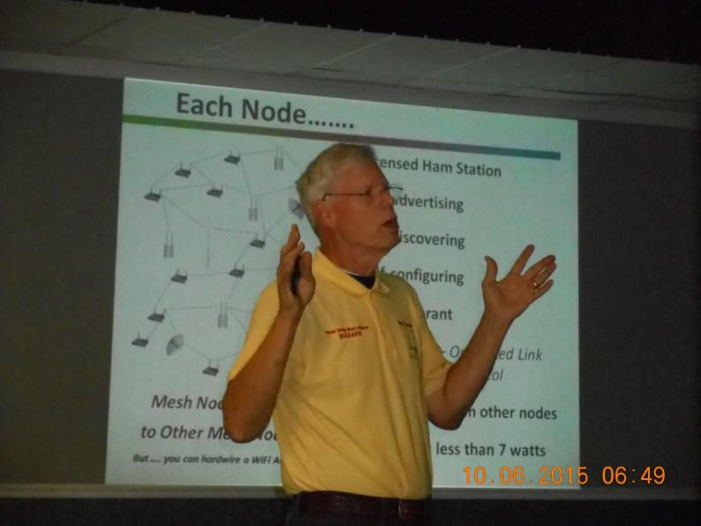
Bill’s presentation described what mesh is, how it works, and how it is deployed and what the different uses are for this network such as:

- Disaster Communication support.

- Public service.

- Support of youth involvement in Ham Radio.

I am going to quote from Bill on just exactly a mesh network is…”Simply put, A Mesh Network is a wireless digital network, made up of repeaters, they call “Nodes”. It runs on microwave frequencies, and its job is to transport digital data at high speeds, just like any other digital network you may use in your home, work, factory, or school”.

(Continued on page 3)
2015 Board of Directors

President
Fred Schneider K9OHE ................. | (513) 729-0945 .......... | fschneider@fuse.net
Vice President
Michael Sien KD8SOH ................. | (513) 312-0691 .......... | Michael.sien@zoomtown.com
Secretary
Ted Morris NC8V ......................... | (513) 731-3451 .......... | nc8v@hotmail.com
Treasurer
Brian DeYoung K4BRI ................. | (859) 635-3095 ......... | k4bri@arrl.net
Directors
Bryan Hoffman KC8EGV .............. | (513) 851-0525 ......... | hoffgroup@gmail.com
Bruce Vanselow N8BV ................ | (513) 251-1555 ......... | n8bv@juno.com
Ryan Williamson W1RYN ............. | ................................... | w1ryn@w1ryn.me
Trustee/Licensee
Bruce Vanselow N8BV ................ | (513) 251-1555 ......... | n8bv@juno.com
Past President
Gary Coffey .................................. | (513) 382-3879 .......... | kb8myc@fuse.net

OH-KY-IN Repeaters

146.670 (-) Clifton

146.625 (-) Edgewood, KY

146.925 (-) Colerain Twp

443.7625 (+5) Clifton

A CTCSS (PL) tone of 123.0 Hz is

required for access to all OH-KY

-IN repeaters. All repeaters also

transmit a CTCSS (PL) tone of

123.0 Hz

APRS on 144.390 mHz

K8SCH-10 Edgewood WIDEn

K8SCH-9 Clifton WIDEn

For membership information, please contact Na-than Ciufo KA3MTT, 6323 Cinnamon Ridge Dr, Bur-lington KY 41005, (859) 586-2435 or Email membership@ohkyin.org. Renewals of Club Mem-berships are due by the end of March.
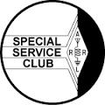

Permission is hereby granted to any amateur radio group to quote or reprint from this publication, if proper source credit is given, unless permission is otherwise reserved.

THE Q-FIVER is now mailed & e-mailed, it's hoped, a week before the club meeting.

Normally copy deadline is the weekend before that. Please send your submissions for THE Q-FIVER (including notice of upgrades & callsign changes) to Brian K4BRI

These may be: snail-mailed to or dropped off at 6901 Backus Drive, Alexandria KY 41001 or telephoned to (859) 635-3095 any time

2

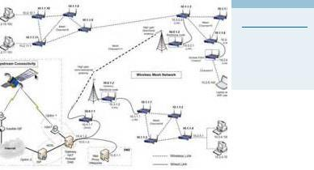Oh-Ky-In Life Members

John Phelps N8JTP

Kenneth E Wolf N8WYC

John W Hughes AI4DA

Karl W Kaucher KJ4KWR

Howard Hunt NG8P

I will again quote right from Bill’s presentation…The above diagram illustrates what a typical Mesh system might look like. I pulled this one off of the internet. “In the diagram Bill presented the top of the diagram was a cluster of mesh nodes, talking to each other. Connected to the mesh are three clients: a computer, an IP TV camera, and an analog telephone adaptor with a plain old telephone. A few of the nodes also have an RF connection to a Node on the tower”.

“At the bottom of Bill’s diagram Bill illustrates a second cluster of nodes, also linked to the node on the tow-er. Clients her include the phone, a raspberry pi with HDTV display and a WIFI access point connected to a smart phone”.

Bill went on to show us:

- What Node spacing should look like.

- What the system might look like.

- An example of what the Fresnel Zone should look like.

- What can run on Mesh

- What are the applications

- What are some of the issues concerning Laws and Regulations

- A list of the supporting organizations.

- A list of equipment to get started.

3

If you are interested in the Mesh Network contact me at Michael.sien@zoomtown.com as many members in the OH-KY-IN,ARS have voiced an interest in learning and starting a Mesh Network. Information will follow on a meeting time and date.

Many thanks go out to Bill for the awesome presentation that he gave to our group. It was riveting to the point we shortened our business meeting just so that Bill could enlighten us on the topic. I will be honest that I have seen two presentations on the topic Bill’s without a doubt was the best!

Thanks for taking the time out to read my article! Every month I like to leave my readers with something to walk away with and this month is no different. Winter will be upon us soon, actually sooner than you think. Here are some helpful hints to make sure that you have a fun winter and that you don’t find yourself making some unwanted repairs:

- Work on those bench projects that you put off this summer.

- Try a new facet of the hobby that you haven’t worked before…for me it will be Mesh, Digital, WIN-LINK, SSTV, or even CW!

- I already have a few friends in the club that want to get together this winter to work on projects…if you’re interested shoot me an e-mail.

- Check your antenna and its structure.

- I know this is going to sound crazy but consider putting your new antenna that you just bought or are contemplating buying up now and not in the winter. Trust me I put my Gap Titan DX up in early Feb-ruary two years ago and every other word out of my mouth was…why didn’t I wait till spring!

- Make sure you check all of your outside connections and your coax. It’s a lot easier to change these things out while it is warm than with snow and it being cold outside.

- If you are looking for your friends to help it is a lot easier to talk them into it when it isn’t freezing cold outside.

As always I leave you with that there are so many fun and exciting activities to do in Amateur Radio. There are still so many things as a club that we want to introduce and accomplish in Amateur Radio with our club members. All we need is you! If you are not already a member please consider joining our club, if you are a member tell a friend about our club and about our hobby and invite them to our meetings and our classes!

73’s and until next month!

Michael L.Sien

Michael Sien – KD8SOH

4

From the President

We have an interesting program for our November meeting. We will learn about using fox hunting and other skills to find transmitters that are causing interference to radio services, malicious interfer-ence, etc. Interference can be to ham radio or other radio services.

DON’T FORGET TO VOTE ON NOVEMBER 3.

Because of the election, we will meet in the basement of the usual building. Enter from the rear parking lot using the door at the end of the concrete wall that starts at the corner of the building.

The ARRL Sweepstakes are in November. I sent you an email earlier. The dates are Nov. 7 – 9 for cw (contact Brian, K4BRI) and Nov 21 – 23 for ssb (contact Eric, N8YC).

You may already read this – ARRL has created a National Parks on the Air event to mark the Cen-tennial of the National Park system. The contest begins on January 1, 2016. There are two catego-ries of entrants – Chaser Award and Activator Award. You can earn a Chaser Award by contacting amateur radio stations that operated in a Nation Park. The more Parks you contact, the greater number of points you earn. You need only one such contact to earn an award, but if you contact more parks, the total number will be printed on you Award. Activator Awards go to amateur stations that operate from a facility operated by the National Park Service. All contacts and status – Chaser or Activatior – must be entered into the Log Book of the World. This is a one year chance at an award, ending on December 31, 2016. Some of you will want to participate.

Nominations for officers for 2016 and one Director will be done at our November meeting. The elec-tion will be at the December meeting/party.

Fred K9OHE President
ARRL Sweepstakes

Just as a reminder, The Oh-Ky-In ARS participation in the 2015 annual ARRL November Phone Sweepstakes is just around the corner!

We will again be hosting this year's Oh-Ky-In ARS event at my QTH, Saturday and Sunday, the 21st and 22nd of No-vember. Phone Sweeps is always conducted on the third full weekend in November, and is the oldest ARRL contest, with this year being the 82nd year. Sweeps is always a challenging and rewarding event, and a historied annual Oh-Ky -In event, always full of great camaraderie.

This contest is, of course, open to anyone who would like to participate.

If you are interested in operating, just let me know and we can work you into the schedule. Typically, we operate starting at 4pm on Saturday and can operate no more than 24 hours with the ending time of 0259 UTC Monday (Sunday Evening) but usually ends in the early afternoon, depending when, and if we are able to complete a full sweep.

A wealth of info about ARRL Sweepstakes can be found at http://www.arrl.org/sweepstakes

Thanks!

Eric, N8YC

5

Foxhunting and ARDF

The October mobile hunt had the two regular hunters, Dick WB4SUV and Janie, and Marji KJ4ZKC & myself, as well as two new teams—Ron WD8VOR, and Howard KD8WOY and Marty KE8CEI. It was great having some new teams trying out foxhunting, and Dick was able to help them out with
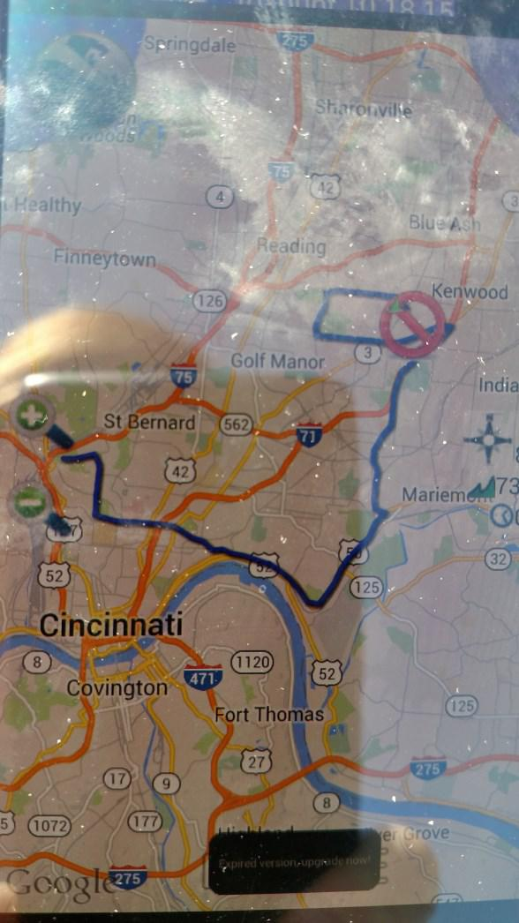
equipment, antennas and ideas.

We started a little late, but had plenty of signal at the start. We headed pretty much straight east, but after losing signal near Lunken airport, we headed north and picked up signal again. Again, I started guessing parks, and Phil was not at French park (again). Heading east the signal really started picking up, and we zeroed in on a park behind Howard Elementary school in Deer Park.

All of the teams found Phil in good time—it was a great day!
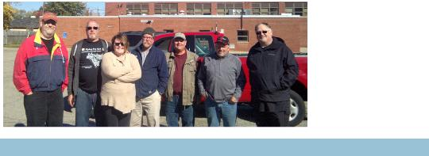

Brunch Bunch
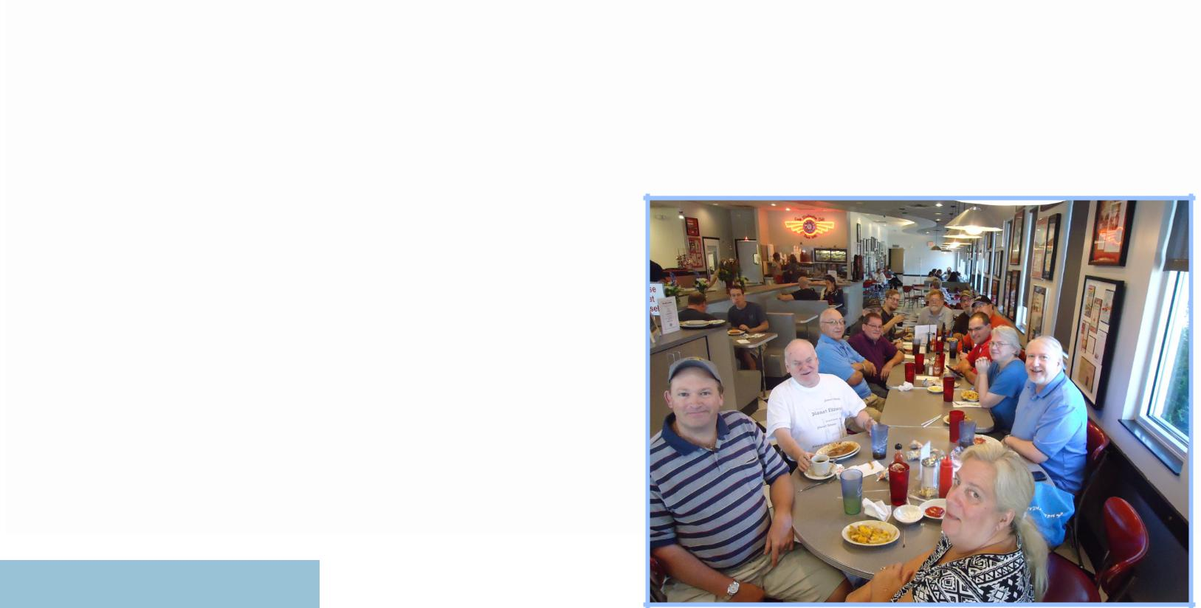

The next Brunch Bunch will be held Saturday, November 14th, at 1pm. The location for November is Steak 'n Shake located at 3835 Race Road in Bridgetown, 45211. Steak 'n Shake is just north of the intersection of Bridgetown and Race Roads.

For a look at the menu as well as a directions, please go to:

www.steaknshake.com

Remember that the Brunch Bunch always meets the second Satur-day of every month at 1pm at a location to be announced each month. If you can't join us this month, maybe you'll be available to join us in the months ahead.

I'm always looking for suggestions on what restaurant you think might be a good place for the Brunch Bunch to visit soon.

73, ……..Bruce, N8BV

6

2015 Committee Chairs and Appointments

Newcomers/Elmers Net ................ | Robert Gulley AK3Q | Q-Fiver Editor ............................ | Brian DeYoung, K4BRI
Technical Committee ................ | Brian DeYoung, K4BRI | Field Day .......................................... | Eric Neiheisel N8YC
ARPSC Representative.................... | Jerry Shipp W1SCR | Historian .................................. | Dale Vanselow KC8HQS
Volunteer Examiners .................. | Brian DeYoung K4BRI | Special Publications ................. | Jo Haltermon KD4PYS
QCEN Representative ...................... | Pat Maley KD8PAT | Fox Hunters .................................. | Dick Arnett WB4SUV
Membership ............................... | Nathan Ciufo KA3MTT | Equipment Mgr ........................... | Brian Fulmer KC8FJN
Fundraising ................................ | Bruce Vanselow N8BV | WebGeezer ............................ | Ryan Williamson W1RYN
Education ....................................... | Robert Gulley AK3Q | Silent Key ................................... | Bruce Vanselow N8BV
Repeater Control Ops Mgr ........ | Bruce Vanselow N8BV | Tech Talk Net Mgr ..................... | Bruce Vanselow N8BV
PIO ........................................................ | Ted Morris NC8V | K8SCH QSL Mgr ......................... | Gerry Weimer KD8ASL
Librarian ................................... | Howard Alban KD8WOY | TV/RFI .......................................... | Dick Arnett WB4SUV

The November Foxhunt has been moved to 12 noon, instead of 10:00 AM start, because of the VE session at 9:00 AM. Come out and check out mobile foxhunting

November Calendar

Sun Nov 1 | 7:00 PM | Newcomers/Elmers Net, 146.67 146.67, Topic: Satellite Listening —NCS Robert AK3Q
Tue Nov 3 | 7:30 PM | Club Meeting at St Bernard Recreation Hall, 120 Washington Avenue.
 |  | Program: Foxhunting
Wed Nov 4 | 9:00 PM | Tech Talk, NCS Robert AK3Q
Sun Nov 8 | 7:00 PM | Newcomers/Elmers Net, 146.67 146.67, Topic: Traffic Handling Stories —NCS Robert AK3Q
Wed Nov 11 | 9:00 PM | Tech Talk, NCS Brian K4BRI
Sat Nov 14 | 9:00 AM | VE Test session—St. Bernard
12:00 Noon |  | Mobile Foxhunt, starting at Mt. Storm park in Clifton—talk in on 146.670
 | 1:00 PM | Brunch Bunch at Frisch's Big Boy Restaurant located at 5216 Glenway Avenue, 45238
Sun Nov 15 | 7:00 PM | Newcomers/Elmers Net, 146.67, Topic: Emergency Services —NCS Robert AK3Q
Wed Nov 18 | 9:00 PM | Tech Talk, NCS Dale KC8HQS
Sat Nov 21 | 4:00 PM | ARRL Sweepstakes SSB—held at Eric’s N8YC
Sun Nov 22 | 7:00 PM | Newcomers/Elmers Net, 146.67, Topic: Public Service —NCS Robert AK3Q
Tue Nov 24 | 7:00 PM | Board of Directors meeting
Wed Nov 25 | 9:00 PM | Tech Talk, NCS Brian KC8FJN
Sun Nov 29 | 7:00 PM | Newcomers/Elmers Net, 146.67, Topic: Let’s Talk (On the Air!) —NCS Robert AK3Q

7

The Elmer’s Corner: There are No Real Antenna Shortcuts

Like most radio folks I have at times wanted to take shortcuts with my antennas for the sake of convenience. One or two guy ropes instead of three; depending on a tuner to “get me in the ballpark” in terms of resonance; using “good enough” coax because the better stuff costs so much, and so on. You get the idea.
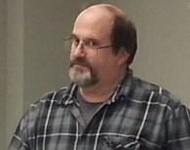
Sometimes the old ways are the best ways. Sometimes, “tried and true” can’t really be improved upon! I will ex-

plore some of these tried-and-true antenna basics which have gotten lost in the blaze and glory of so-called technological advance-ments, in hopes of bettering our lives through simplicity.

Feeding Multiband Antennas

A multiband antenna may be necessary based on one’s logistics, and there is certainly nothing wrong with them, but are you willing to go the extra mile to make sure the antenna is set up properly, from design to support structure to feedline? Multiband antennas can have a number of compromises, so any shortcuts taken can lead to big problems down the road.

Multiband antennas by their nature have to sacrifice some efficiency since antennas can only be truly resonant on one frequency at a time, but this does not mean they cannot be used. They do require more attention to detail than a monoband dipole, for exam-ple, but this is to be expected since you are getting more out of the antenna.

One of the places where shortcuts are most common is in the feedline. Coax feedlines are as ubiquitous in amateur radio these days as cell phones in an airport. Coax is quick and easy to install, and promises of low-loss construction are inviting. When coupled with a tuner in the shack the world seems to be a beautiful place, especially if the tuner is one of the computer-controlled push-of-the-button kind. A series of clicks, some buzzing, and a satisfying mellifluous tone, and we are off to the races!

But what is happening inside the coax as the signal traverses down this magical mass of metal? On multiband antennas our old nemesis impedance rears its ugly head. Capacitive reactance and inductive reactance must be cancelled out leaving only resistance for our antenna to be resonant. Anything else means there is additional resistance to the signal in the form of reflected power.

A tuner in the shack matches impedance at the radio so that the radio “sees” the impedance it needs to send full power output. Impedance changes with frequency, and there is also insertion loss (the cumulative effects of coax imperfections and signal attenu-ation).

Furthermore, the match between the tuner and the radio only exists between the cable which attaches your tuner to your radio. The coax between your tuner and the antenna represents higher losses, particularly as you move away from the antenna’s reso-nant frequency.

A good, old-fashioned option is to use ladder line for the feedline, even for runs under 100 feet. “What’s that?” you ask? “I thought short runs of coax had minimal losses?”

While good quality coax losses seem insignificant under this length, remember the issue is impedance added by the antenna not being cut to resonance. Even with a tuner coax losses can be significant for non-resonant frequencies. The losses for ladder line are so minimal that the losses will be negligible even at different frequencies. (By the way, a common misconception is that ladder line radiates signals, but this is not true if the antenna wires are balanced, viz. the same length and in the same plane with the feedline at 90°.)

Using a balanced tuner at the station with ladder line means most of your power will actually make it to the multiband antenna, and non-resonant bands will work better.

A common practice with ladder line is to twist it one turn every few feet to prevent effects from wind and to reduce strain on the ladder line. This will in no way affect the signal going out (or coming in).

(Continued on page 9)

8

(Continued from page 8)

Feedlines can be susceptible to RF coming back into the shack (but so can coax). Use a length of feedline which is not a half-wave multiple of the desired bands. A common length is 43’ or 86’. It can have conductive issues unless you are careful to keep it away from other metal surfaces. A typical rule of thumb is to maintain a distance of twice the width of the feedline from metal objects. This is not really hard, as any non-conductive material can be used as a spacer. PVC pipe works well.

Antenna Supports

Antennas are fragile in the big scheme of things. I wish I could put up one of those mighty self-sustaining towers, but I live where those are not allowed. Probably a good thing, too. I heard an old-timer comment on the air the other day “The bigger the antenna the bigger the problems.” I reflected on that for a few moments to appreciate the wisdom.

The best part about a 60’ tower with a larger beam antenna is that the antenna is up 60’ and should reach out and touch someone! The worst part about the antenna is that it is 60’ up in the air when something goes wrong. A friend of mine had a malfunctioning beam 60’ up in the air and it took several months for him to be able to fix it due to weather conditions and the need to find a tower climber.

I had a 32’ wire antenna on a mast which was damaged by wind, and within a day or two I was able to get it up and working again. There is something to be said for simplicity! However, pride cometh before a fall, and lest you think I am being prideful, I must has-ten to add my antenna came down because it only had two guy wires instead of three or four. A silly mistake, but one which I will not soon forget.

Over the years I have had several antennas taken down by strong wind because I took shortcuts with their supports. The most re-cent casualty was a 6-meter antenna which did indeed have three guy wires supporting it, but needed three more near the top of the antenna.

Three to four guy ropes are a minimum to limit movement in any direction, but sometimes two or more sets of these guy ropes need to be in place to minimize movement. If you are using fiberglass poles as I have done in the past, keep in mind these can get brittle over time through exposure to the elements, and therefore need to be protected from flexing as much as possible.

We routinely have 30-40 mph winds here, with gusts up to 50+ mph at times. Most of my antennas are quite solid even in these winds, but a few antennas I “threw” up in haste or with inadequate guying support have been the ones to come down.

These are just a few shortcuts to avoid – I am sure we will revisit the topic down the road! Hopefully you can avoid some of my foolish shortcuts and be able to enjoy the hobby all the more. And maybe, just maybe, we can share our mistakes with each other so we all benefit!

73, Robert AK3Q

DX
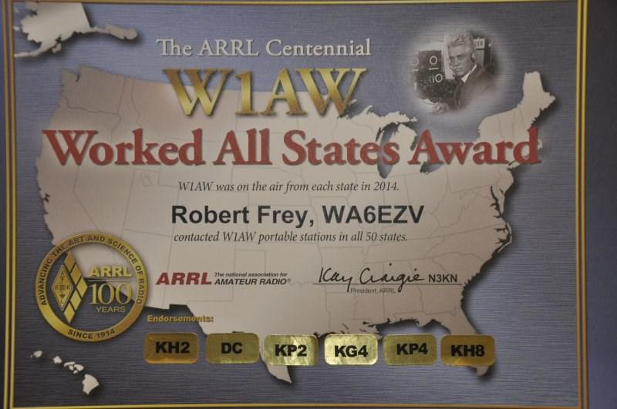
At the start of 2014 I decided to work the W1AW portable sta-tions and try for a sweep. Well I did a lot better that expected con-sidering all I was running was an end fed 24 foot piece of wire and my TF950 at 90 watts. Final results were a sweep on SSB and CW and 45 states on RTTY. I even managed to add the six endorse-ments. Who says you can’t have fun as a little pastel. Hi Hi.

Bob, WA6EZV

9

OH-KY-IN Amateur Radio Society

Regular monthly meetings are held the first Tuesday of each month at 7:30PM local time at the St Bernard Recreation Hall, 120 Washington Avenue (corner Washington & Tower Aves) in St Bernard, just east of Vine St. Please come in the doors at street level, facing the high school. Visitors are ALWAYS welcome!

.
The next meeting of the Oh-Ky-In Amateur Radio Society will be Tuesday, November 3rd at 7:30 PM

The program for the November General membership meeting will be Foxhunting, given by our own world-renown foxhunting expert— Dick, WB4SUV.

Since our meeting date is also election day, we will meet in the base-ment of the usual building. Enter from the rear parking lot using the door at the end of the concrete wall that starts at the corner of the building.

OH-KY-IN Amateur Radio | PLEASE
Society | PLACE
 | STAMP
Q-FIVER Editor | HERE
Brian DeYoung, K4BRI
6901 Backus Drive
Alexandria, KY 41001
Phone: (859) 635-3095
Web: www.ohkyin.org
E-mail: k4bri@arrl.net
