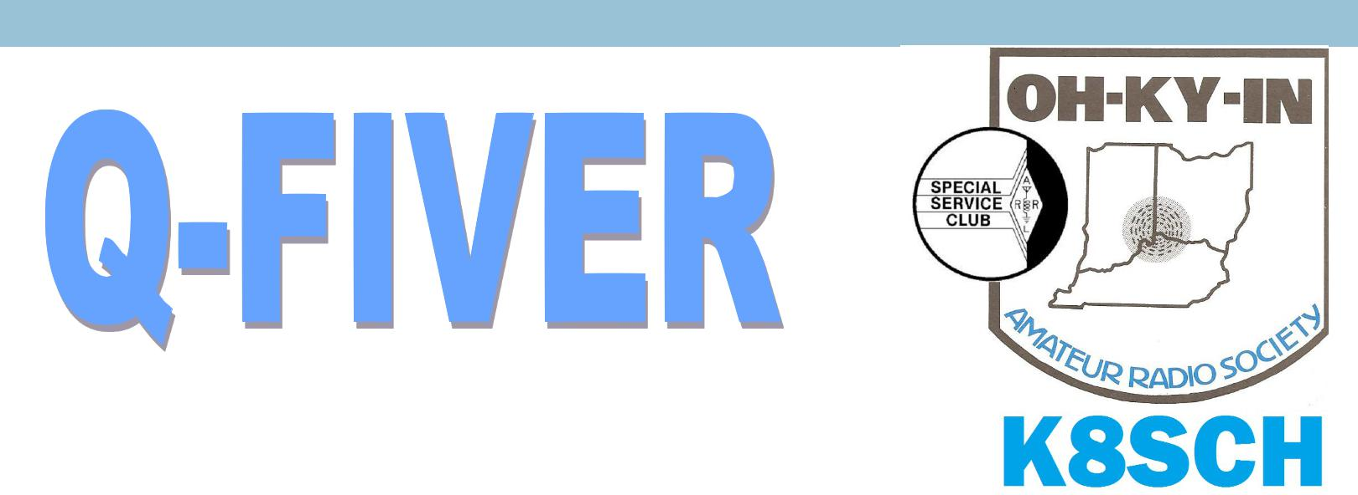OH-KY-IN Amateur Radio Society | October, 2015
 | Volume 55, Issue 10

The Official Newsletter of the OH-KY-IN Amateur Radio Society
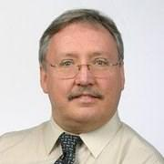

From the V/P’s desk….A September to Remember!

As I sit down to write this article the month of September is almost in the log books! This year is flying by and in three more months my job as Vice President will be coming to an end! This has been an exciting year and we have had some great speakers and presentations. This month was no exception as we had the pleasure of hosting Scott Yonally, N8SY ARRL Section Manager.

At OH-KY-IN, ARS we call this ARRL night and it allows us to connect with the organization that does so much for our hobby, our club, and for our fellow amateur radio brothers and sisters. Once again Scott did not let us down as he started off with a video from the American Electric Power Company. The video went into how we get our natural electricity; it went into explaining the difference between 3 phase vs. single phase lines. More importantly it went in to the different scenarios on what could happen if you don’t give electric-ity the respect it deserves the consequences could be deadly!

Scott finished off with a power point that shared some very interesting facts that many of us did or did not know such as:

- There are 31,000 licensed amateurs in Ohio.

- Ohio is the largest section in the ARRL

- Ohio has 1,700 members in Ohio.

Scott went on to talk about his web-site www.arrlohio.org and asked us to check it out if we haven’t done so and to go to the Ohio Section Journal to opt in to get the news feed letter. He went on to remind us to shop Amazon Smile as a percentage of the sales go to the ARRL.

He closed up his presentation by discussing just some of the things that the ARRL is involved in and are working on and they are as follows:

(Continued on page 3)
2015 Board of Directors

President
Fred Schneider K9OHE ................. | (513) 729-0945 .......... | fschneider@fuse.net
Vice President
Michael Sien KD8SOH ................. | (513) 312-0691 .......... | Michael.sien@zoomtown.com
Secretary
Ted Morris NC8V ......................... | (513) 731-3451 .......... | nc8v@hotmail.com
Treasurer
Brian DeYoung K4BRI ................. | (859) 635-3095 ......... | k4bri@arrl.net
Directors
Bryan Hoffman KC8EGV .............. | (513) 851-0525 ......... | hoffgroup@gmail.com
Bruce Vanselow N8BV ................ | (513) 251-1555 ......... | n8bv@juno.com
Ryan Williamson W1RYN ............. | ................................... | w1ryn@w1ryn.me
Trustee/Licensee
Bruce Vanselow N8BV ................ | (513) 251-1555 ......... | n8bv@juno.com
Past President
Gary Coffey .................................. | (513) 382-3879 .......... | kb8myc@fuse.net

OH-KY-IN Repeaters

146.670 (-) Clifton

146.625 (-) Edgewood, KY

146.925 (-) Colerain Twp

443.7625 (+5) Clifton

A CTCSS (PL) tone of 123.0 Hz is

required for access to all OH-KY

-IN repeaters. All repeaters also

transmit a CTCSS (PL) tone of

123.0 Hz

APRS on 144.390 mHz

K8SCH-10 Edgewood WIDEn

K8SCH-9 Clifton WIDEn

For membership information, please contact Na-than Ciufo KA3MTT, 6323 Cinnamon Ridge Dr, Bur-lington KY 41005, (859) 586-2435 or Email membership@ohkyin.org. Renewals of Club Mem-berships are due by the end of March.
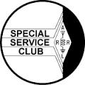

Permission is hereby granted to any amateur radio group to quote or reprint from this publication, if proper source credit is given, unless permission is otherwise reserved.

THE Q-FIVER is now mailed & e-mailed, it's hoped, a week before the club meeting.

Normally copy deadline is the weekend before that. Please send your submissions for THE Q-FIVER (including notice of upgrades & callsign changes) to Brian K4BRI

These may be: snail-mailed to or dropped off at 6901 Backus Drive, Alexandria KY 41001 or telephoned to (859) 635-3095 any time

2

(Continued from page 1)

- H.R. 1301 S1685

- Ohio Antenna Law

- Simulated Emergency Test

- ARRL dues increase

- ARES

- Ohio 2 – Proposed Distracted Driving Legisla-tion

- Vanity Call

- Republican National Convention

I know that I speak for a lot of amateur radio op-erators when I say that we owe a great debt of thanks to the ARRL for its hard work and dedica-tion to great hobby we love!

Oh-Ky-In Life Members
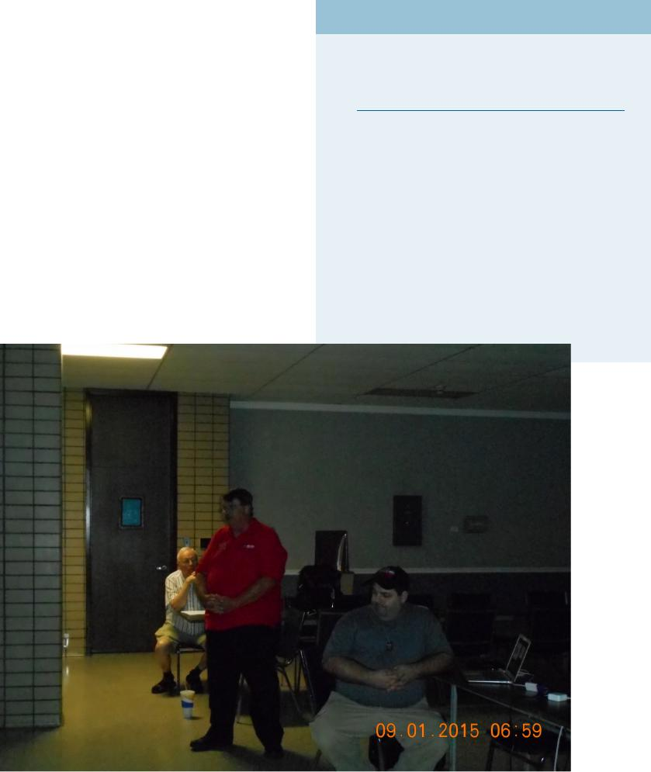
John Phelps N8JTP

Kenneth E Wolf N8WYC

John W Hughes AI4DA

Karl W Kaucher KJ4KWR

Howard Hunt NG8P

Ohio State Parks on the Air

On September 12, 2015, I got the opportunity to participate in the Ohio State Parks on the Air contest that Jerry Shipp W1SCR and Bobby Revis KD8TPU coordinated under the call sign K8SCH the OH-KY-IN, ARS. We had a great turnout with 8 club members ready to get set up and to operate the contest! It was an overcast day a great day to test out our NVIS antennas.

We were located at Stonelick State Park and had plenty of room for our antennas and a nice shelter to stay dry under. Trust me that shelter came in handy as we saw our fair share of rain and showers! Through it all we managed to get 95 QSO’s with a multiplier of 39 State Parks for a score of 3,705 points. I am anxiously waiting to see how we placed but we are already winners in my book! We had a total 5 radios and 3 of them all set up and ready to go at 12 o’clock the other two shortly after. This is definitely a contest we will do again next year!

None of this could have been possible with the help of the following Club Members:

- Jerry Shipp – Getting us signed up for the contest.

- Bobby Revis – Reserving the shelter at Stonelick Lake State Park.

- Mike Niehaus – Set up and operator.

- Ted Morris – Set up and operator.

- Greg Vicars – Set up and operator.

3

- Jason Nivens Sr. – Set up and operator.

- Jason Nivens Jr. – Set up and operator
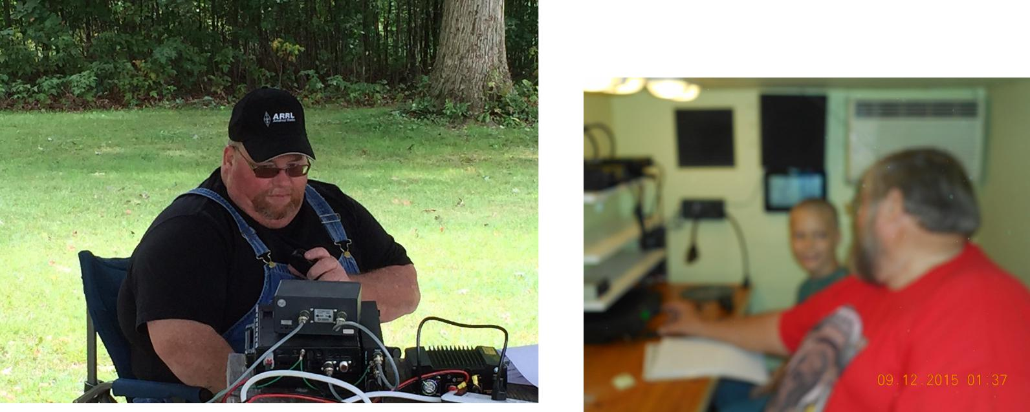

Everyone above was a key to our success and I can’t wait for us to get together next year and do it again! This was like a small version of Field Day…If Field Day sounds a little intimidating and you would love to be a part of something on a smaller scale next year I hope to see you at this event!

Thanks for taking the time out to read my article! Every month I like to leave my readers with something to walk away with and this month is no different. Prior to this article we received an e-mail notifying us that our membership is up to 141 members! Why is that important and exciting to me? Well it is because I will be running for President of this club in November.

We have had great leadership in this club trust me 141 members doesn’t happen overnight. It happens with a dedicated Officer Line and Board of Directors with one single goal in mind making this club the best club and our repeaters the best it can be for its members!

I leave you with that there are so many fun and exciting activities to do in Amateur Radio. There are still so many things as a club that we want to introduce and accomplish in Amateur Radio with our club members. All we need is you! If you are not already a member please consider joining our club, if you are a member tell a friend about our club and about our hobby and invite them to our meetings and our classes!

73’s and until next month!

Michael Sien – KD8SOH

4

Minutes of the September 1st 2015 Regular Meeting

CORRECTIONS TO PREVIOUSLY PUBLISHED MINUTES:

FOR MAY 5, 2015 REGULAR MEETING: These appeared properly in the June 2015 Q-Fiver but with an erroneous “April 7, 2015” title.

FOR AUGUST 4, 2015 REGULAR MEETING: The packet station at the Withamsville tower site has been assembled and maintained by Bruce Vanselow N8BV, and uses the club callsign K8SCH. The Red White and Blue Ash crew list missed Lynn Ernst WD8JAW, and erroneously included Gary Coffey KB8MYC. The Raspberry Pi and Pi 2 microcomputers were described in the presen-tation as being more powerful than early PCs.

President Fred Schneider K9OHE called the September 1, 2015 regular meeting to order at 7:33 P.M., followed by the Pledge of Allegiance.

Fred introduced Howard Alban KD8WOY as our new Librarian. Howard brought to the meeting some of the library materials for inspection, and handed out a list of current ARRL publications available from the League so folks could consider what of those items we should add to the collection. He plans to add this list to the Website, and possibly the Q-Fiver. Along with suggestions of what to add to the collection, Howard seeks suggestions of items to remove.

Howard plans to bring a portion of the Library collection to each meeting for folks to examine. They can checkout materials and return them at each meeting. If folks want particular items, they should call ahead so he can bring them to the next meeting.

Self-Introductions included one visitor wanting to get a license, and our presenter.

Presentation: Ohio Section Manager, Scott Yonally N8SY started with a safety demonstration video produced by utility company AEP. It demonstrated many of the ways hams might find themselves in dangerous situations relating to our electric power service.

From Scott’s following PowerPoint slides we learned there are ~31,000 licensed hams in the Ohio Section; we are the largest ARRL Section; and as of August there are ~1,700 ARES members in the Section. He also noted that Ohio is the first state to implement ARES Mutual Assistance Teams (MAT). Many countries around the world, and locations here in the US, are looking to hams for communications help.

These data are available from the Ohio Section website Scott maintains at www.arrl-ohio.org, which he recommends we use as our home page because of its useful links. He also promoted the use of his blog, also available at the website or by RSS feed.

Scott circulated pamphlets regarding the Amateur Radio Parity Act of 2015 (H.R. 1301, S 1685), and urged us to write our congres-sional delegations letters of support for these bills. However, he noted that we will achieve a greater impact if those letters are sent in care of the ARRL, to be delivered in person en masse. This is because individual mail pieces take a long time to get through security screening and passed on to their congressional addressees.

Scott offered his regrets that he will not be able to attend our Hamfest on September 19, but he did announced that Assistant Sec-tion Manager Kitty Hevener W8TDA will represent the League at their information table. As he closed his presentation, he provid-ed a generous door prize—an extensive portable first aid kit, and a small seat cushion (appliquéd with “CQ”) useful for long de-ployments. These were provided in a cloth ARRL ote bag.

After those assembled thanked Scott his time and efforts, a ten-minute break was called at 8:42 P.M.

Upon reconvening at 8:54 P.M., President Fred Schneider K9OHE asked for any “Brag Session” comments.

- Bryan Hoffman KC8EGV reported he had recently attended some ICS classes.

(Continued on page 6)

5

(Continued from page 5)

- Brian DeYoung K4BRI and Dick Arnett WB4SUV recently participated in the 2015 USA/IARU Region 2 ARDF Champion-ships, along with three other Ohioans. All five won medals!

- Dick noted that several club members (who wish to not be named) were among those who assisted the FCC’s recent iden-tification of a jammer in the area.

- Jerry Shipp W1SCR will visit the Titan Missile Museum soon. Among its attractions is a giant antenna folks can use with their ham gear. He plans to send more information via the reflector.

Minutes of the August 4, 2015 Regular Meeting were approved pending several changes [See “Corrections” at the beginning of these minutes—Sec’y].

Treasurer Brian DeYoung K4BRI’s report was unanimously approved.

Membership: Fred K9OHE noted that Nathan Ciufo KA3MTT’s latest roster counts 131 members.

Education: Fred reported that a committee chair is still needed. [Classes for the Amateur Extra license begin September 14th. Gen-eral and Technician license classes begin October 12th, with VE testing November 14th.—Sec’y]

Brunch Bunch: Bruce Vanselow N8BV announced our regular 2nd-Saturday get-together will take place on September 12th, at the Price Hill Frisch’s at 1 P.M.

Fox Hunts: Brian K4BRI reported on August’s Fox Hunt and noted that two are slated for September: our usual 2nd Saturday morn-ing event leaving Mt. Storm park precisely at 10 A.m., and another during the September 19th Hamfest.

Website: Fred K9OHE thanked Ryan Williamson W1RYN on behalf of the club for taking on the role of Webmaster. Ryan asked the group what we would like to see that’s not there now. For example, a Members-Only section might provide access to an online version of our roster. How this would be implemented (security, password access, individual user accounts, etc.) would need to be considered among other factors.

The website as it stands is extremely “hard-coded,” and Ryan W1RYN would like to see us move toward a system environment that would support “push” technology, offering Wordpress as an example. This would also assist in providing security arrange-ments due to how they are set up. In further discussion:

- Ryan noted he wants to see other club members be the “content pushers,” rather than have all content funneled through the Webmaster.

- Paul Jordan KD8JDF inquired about compatibility with screen readers. Ryan noted that Wordpress, as an example, works well with the widely-used program JAWS.

- Brian K4BRI moved (Dick WB4SUV second) that we set up a test site on Wordpress. This would give folks a chance to see if features they want to see in a club website are do-able in a leading blogspace environment. The motion was APPROVED unanimously. We now need a few volunteers to assist in exploring what the website should have.

Facebook: Ryan W1RYN reported he has mounted a prototype Facebook presence for the club. He noted that social media such as Facebook and Twitter are important tools for sharing information quickly. He referred to the ARRL’s Facebook efforts and our Pre-senter Scott Yonally N8SY’s blog accessed by the Ohio Section website. Issues brought up included:

- Screen readers don’t handle Facebook well.

- The big draw to using Facebook, Twitter, etc., is their ability to disseminate information quickly.

- YouTube was mentioned as an example of a strong “content draw”; however, others noted that creating useful videos takes a lot of work.

(Continued on page 7)

6

(Continued from page 6)

- Using Facebook would give us a free publicity medium. As we post information, others can comment and share those postings with their own circle of “Friends.” We get wider exposure and broaden our public relations net.

- Susie Scott, N8CGM, recounted her difficulty trying to set up advertising for the Hamfest on Facebook, noting there can be many problems to work out to get the results we’re looking for.

QCEN: Liaison Pat Maley KD8PAT announced their next meeting will be Friday September 18th at the Red Cross building. Folks can arrive as early as 5:30 P.M. to “play” in the radio room; the meeting begins at 7:30 P.M.

Changing hats, Pat—speaking for the Health Department radio group, announced that on Labor Day, Monday September 7th, they will meet on the air as usual at 7 P.M. on the OH-KY-IN 146.670 K8SCH repeater.

Hamfest: Chair Gary Coffey KB8MYC reminded us that the September 19 Hamfest is almost here. He encourages members to sell and buy more tickets. He highlighted several Hamfest features, including the ARRL Forum with Great Lakes Division Vice Director Tom Delaney W8WTD and ARRL information table, the Fox Hunt, and our door prizes. He noted that to date we have presold ~²/₃ of the available rectangular tables.

Gary asked for helpers—and will also put out a call on the reflector—noting we particularly need folks early, to help vendors, flea marketers, and shoppers move in and get situated smoothly. We also need help at the end to break down the setup. The Com-mittee plans to meet again Tuesdays at 7 P.M. at Aiken High School on September 8th and 15th.

Operating Events: Fred K9OHE recounted the successes of our NVIS Antenna Test in April, and announced that our operations for the Ohio State Parks On The Air will take place from Stonelick State Park in Northeast Clermont County. We will use the Grant Fam-ily shelter and Bobby Revis KA8PUI will have signs posted at strategic entry points to the Park. Michael Sein KD8SOH will be cooking out and he asked that folks RSVP so he can plan how much food to buy.

Fred also mentioned that we participated in the Ohio QSO Party in August, operating from a shelter in St. Bernard’s Ross Park. Members also served as communicators for the Cystic Fibrosis Foundation bicycle races in August, coordinated by Michael KD8SOH.

VE Testing: Brian K4BRI called for VEs to help with our testing event at the September 19th Hamfest at 8:30 A.M.

Scott Yonally N8SY’s gift was won by Ted Morris NC8V, who noted his cat is named “CQ” just like on the pillow. Split-the-Pot went to Walter Knauber NA8R. who won $40.

The meeting adjourned at 9:35 P.M.

Respectfully Submitted,

Ted Morris, Secretary

7

Foxhunting and ARDF

The September mobile hunt had the two regular hunters, Dick WB4SUV, and Marji KJ4ZKC & myself. Howard KD8WOY said he would be listening but was not at the start - but he did finish! :)

This month’s lesson—always listen to your lovely wife!

Good signal at the start—Marji measured about 75 degrees but idiot me really thought it was about 120 de-grees—so off we went. Going directly east trying to get on that side of town, we visited Ault Park, many plac-es around Newtown, Mt Washington, Lunken, etc etc. OK I was wrong—heading more north the signal start-ed picking up. Driving up 71 around Kenwood mall—Phil calls my cell phone and asks if we are ok. OK I was way wrong, ok? Narrowing down on the Reagan, I think French Park—nope wrong again. Driving in smaller circles, I finally stumble on a small park (Bechtold Park in Blue Ash) and there he is—way too long of a time. Standing there talking to Phil, and Howard
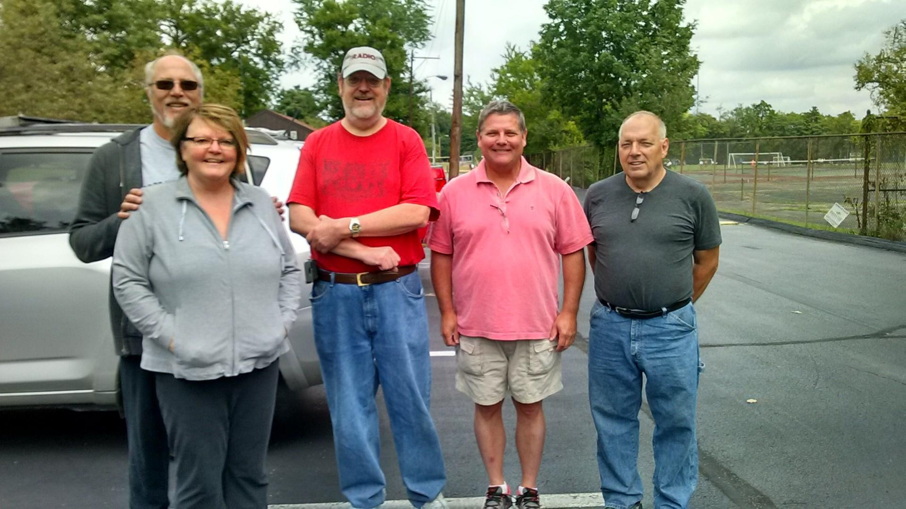
drives up—he found Phil also—Way to go Howard! A new foxhunter is born.

Next month the hunt will be on Sunday the 18th—10AM start from Mt Storm, setup around 9:30 and I will listen to Marji this time—I promise!

Brunch Bunch
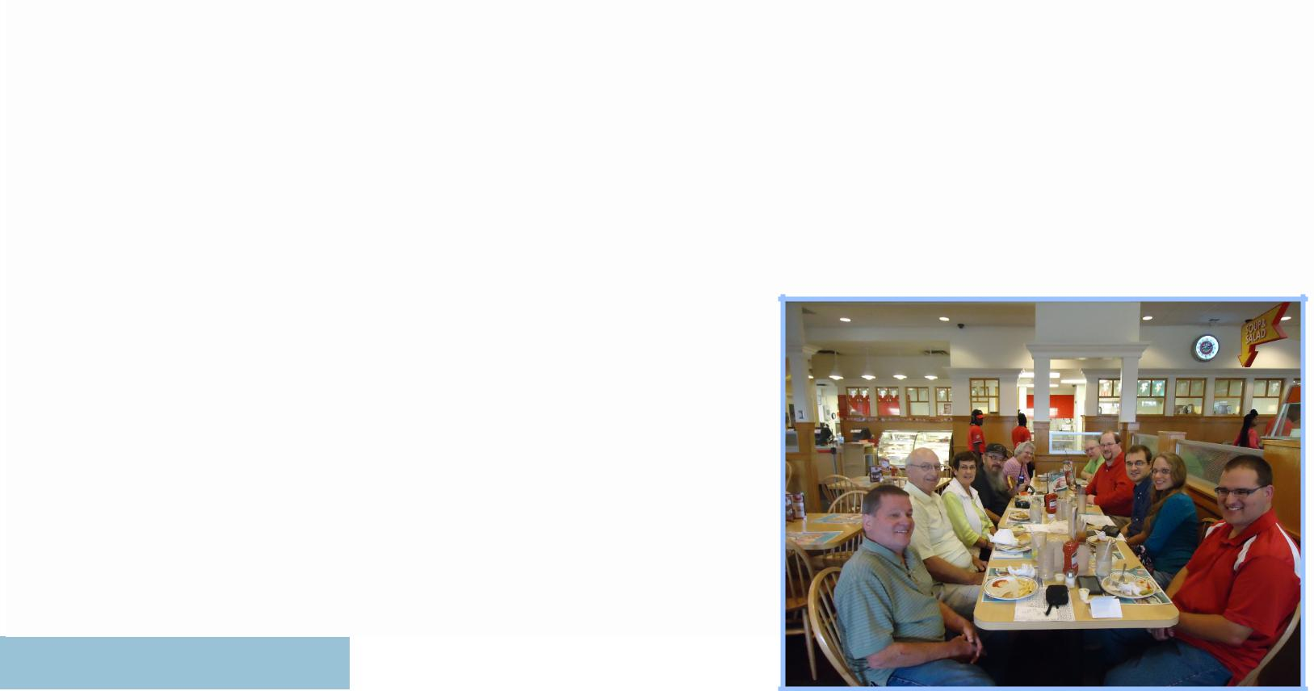
The next Brunch Bunch will be held Saturday, October 10th, at 1pm. The location for October is Camp Washington Chili located at 3005 Colerain Avenue, 45225.

Since 1940, Camp Washington Chili has been proudly serving ”chili-heads” from Cincinnati and all over the world from the corner of Hopple and Colerain Streets, in the heart of Cincinnati’s Camp Washington neighborhood. While our secret chili recipe speaks for itself, there are other ingredients that help make Camp Washington Chili the premier chili parlor in Cincinnati.

For a look at the menu as well as a map, please go to:

www.campwashingtonchili.com

Remember that the Brunch Bunch always meets the second Saturday of eve-ry month at 1pm at a location to be announced each month. If you can't join us this month, maybe you'll be available to join us in the months ahead.

I'm always looking for suggestions on what restaurant you think might be a good place for the Brunch Bunch to visit soon.

73, ……..Bruce, N8BV

8

2015 Committee Chairs and Appointments

Newcomers/Elmers Net ................ | Robert Gulley AK3Q | Q-Fiver Editor ............................ | Brian DeYoung, K4BRI
Technical Committee ................ | Brian DeYoung, K4BRI | Field Day .......................................... | Eric Neiheisel N8YC
ARPSC Representative.................... | Jerry Shipp W1SCR | Historian .................................. | Dale Vanselow KC8HQS
Volunteer Examiners .................. | Brian DeYoung K4BRI | Special Publications ................. | Jo Haltermon KD4PYS
QCEN Representative ...................... | Pat Maley KD8PAT | Fox Hunters .................................. | Dick Arnett WB4SUV
Membership ............................... | Nathan Ciufo KA3MTT | Equipment Mgr ........................... | Brian Fulmer KC8FJN
Fundraising ................................ | Bruce Vanselow N8BV | WebGeezer ............................ | Ryan Williamson W1RYN
Education .......................................................................... |  | Silent Key ................................... | Bruce Vanselow N8BV
Repeater Control Ops Mgr ........ | Bruce Vanselow N8BV | Tech Talk Net Mgr ..................... | Bruce Vanselow N8BV
PIO ........................................................ | Ted Morris NC8V | K8SCH QSL Mgr ......................... | Gerry Weimer KD8ASL
Librarian ................................... | Howard Alban KD8WOY | TV/RFI .......................................... | Dick Arnett WB4SUV

The October Foxhunt has been moved to the third Sunday to accommodate eve-ryone who wants to participate—come out and see what it is like!

October Calendar

Sun Oct 4 | 7:00 PM | Newcomers/Elmers Net, 146.67, Topic: Why Work Contests? —NCS Robert AK3Q
Tue Oct 6 | 7:30 PM | Club Meeting at St Bernard Recreation Hall, 120 Washington Avenue.
 |  | Program: MESH Networks
Wed Oct 7 | 9:00 PM | Tech Talk, NCS Robert AK3Q
Sat Oct 10 | 1:00 PM | Brunch Bunch at Camp Washington Chili located at 3005 Colerain Avenue, 45225
Sun Oct 11 | 7:00 PM | Newcomers/Elmers Net, 146.67, Topic: Finding a Partner (No, not a Dating Service!) —NCS Robert AK3Q
Tue Oct 13 | 6:00 PM | Technical Committee meeting—146.670 Repeater site—Hopefully installing System Fusion repeater
Wed Oct 14 | 9:00 PM | Tech Talk, NCS Brian K4BRI
Sun Oct 18 | 10:00 AM | Mobile Foxhunt—Start at Mt. Storm park in Clifton—talk-in on 146.670
 | 7:00 PM | Newcomers/Elmers Net, 146.67, Topic: Inexpensive Ways to get on HF —NCS Robert AK3Q
Wed Oct 21 | 9:00 PM | Tech Talk, NCS Dale KC8HQS
Sun Oct 25 | 7:00 PM | Newcomers/Elmers Net, 146.67, Topic: Working Nets - a Review —NCS Robert AK3Q
Tue Oct 27 | 7:00 PM | Board of Directors meeting
Wed Oct 28 | 9:00 PM | Tech Talk, NCS Brian KC8FJN

9

The Elmer’s Corner
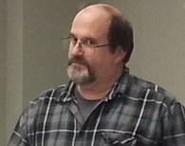

Elmers Corner: Another Golden Age of Radio?

By Robert AK3Q

I will be the first to say I regret terribly missing out on the 60s and 70s era of radio, not only for the stories I hear told about the propagation conditions, but also on the ability to build kits and work with some of those now-

classic radios. Since boat anchors are still plentiful I can recapture a bit of that time, but of course I did not live through it as an am-ateur radio operator.

Perhaps I am the eternal optimist when it comes to radio, but in many ways I feel as though we are in another "Golden Age" of Radio in that we have a true multitude of options open to us which allow us to participate at almost any level. By this I mean equip-ment costs continue to come down while features and capabilities climb. Compare the cost of a good transmitter today (easily within $500-800 for a new highly capable radio) to what they cost back then, and the difference is amazing. Radios cost as much as some cars back then. And while you can still buy a radio that tops $10,000 today, there is no need to go anywhere near that price to get 90% of its capability. When looking at the used market, prices are even better (there will always be rip-off artists, so buyer beware!).

A friend of mine, Ron KD8AFH recently purchased an entry-level Yaesu and has found it to be an excellent radio, and his findings agree with all I have heard about these radios. He very well may have found his first and last HF radio for under $800 current price, as I recall. This radio has features the best of the best could only dream of having back in the 60s or 70s because the technology simply did not exist then. So price ratio to feature set is one reason I say we are in a great time for the radio hobby.

Another reason is because there have been significant strides made in the area of software-defined radios, or SDRs, which only a few short years ago also simply did not exist. While it is true a number of radios have for years incorporated computer chips and programming "behind the scenes," full-blown SDRs are nothing short of amazing even at this early stage, with a lot more progress to come. Again price-points have plummeted over the last two years, and the quality and capability of what is available has sky-rocketed.

For $25 and a decent VHF/UHF antenna the SDR dongles are an incredible steal in terms of capabilities and free software options. For another $25-30 you can add HF capability and have a full-blown all-mode radio receiver that is completely portable and con-trollable through software on a laptop or tablet. Beyond the capabilities of the USB Dongle, this unit and ones similar to it have two antenna connectors so that there is no need to swap out antennas when switching between VHF and HF. The unit is also enclosed in a metal box which provides more shielding to the electrical components inside, which in turn provides cleaner signals and stronger reception. I noticed a significant increase in the number of airplanes I have been able to monitor just by having this unit over the dongle stick.

Since the size is about equivalent to a small deck of cards the unit is highly portable and lightweight, which means it is great for travel. Most of us travel with some means of computing, such as a laptop or a tablet, and this will work fine on any Windows ma-chine.

Will this receiver rival a decent shortwave or amateur radio? Not by a long shot. But it does have some advantages over a tradition-al radio for those times when capability and/or convenience are more important than signal quality.

First there is the coverage which goes somewhere around 100 kHz through 1.7 GHz, yes, Gigahertz! That's a whole lot of radio in one package. With software packages freely available on the Web there is the capability to use it for shortwave, amateur, broad-cast, utility, aeronautic, military, public service, maritime and AM monitoring just to name a few. Signals can be seen over a water-fall or as with a spectrum analyzer, and audio may be easily captured for later analysis.

10

(Continued on page 11)

(Continued from page 10)

Stepping up about $100 there is another SDR unit which has only recently come on the market which is a giant leap forward in terms of quality, the SDRPlay. It retails for $149, has much broader bandwidth coverage at a single time, and of course has better filters and ADC capability. The wider bandwidth coverage means you can record whole swaths of a band and then later analyze each signal one by one. On a similar radio I once recorded about 2 hours’ worth of the entire AM radio band, and can play each station to listen for IDs and programming. I did this on a particularly quiet night atmospherically, because it is rare at my location.

The same capability could allow one to record whole sections of the HF band to study propagation conditions on a given day, catch short burst transmissions such are used in military and civilian aeronautical communications, or record an evening's worth of police and fire calls as just a few examples. Try that with a traditional radio - you simply cannot do it, period!

Software

Software is another area where advances have made contacts with distant stations during poor propagation conditions almost a snap. No longer do we have to rely on CW as the only means of getting through tough reception conditions. Now we can use soft-ware designed to hear moon bounce contacts right on our own computers to enhance contacts around the world with literally mil-liwatts. Various digital modes are being created all the time with more and more capabilities, most of them free to the amateur radio community.

There are software packages for monitoring the airwaves such as Multipsk which rivals the best commercial-grade software for around $50. With dozens and dozens of modes, features which would take page after page to describe, use with a traditional radio is already amazing. Add to the mix an advanced SDR such as the SDRPlay or the next level-up Elad FDM-S2, and the capabilities are astonishing.

Logging software, online QSL services, automated award pages, satellite programs, APRS, D-Star, Echolink and IRLP, and the ability to talk to people around the world from our HT is an amazing thing. And while we may not have Heathkit around anymore, there are many radio kits which can be built with an unprecedented level of design control. We even have access to 3-D printers now which is going to revolutionize how we interact with the world. Who will build the first 3-D printed radio? It won't be long!

There are far more opportunities to enjoy the hobby than I have time for, and I do not see the hobby slowing down one bit. Has it changed since the 60s and 70s? You bet! Is it better? No, just different. But I am here now, in this place and time, and I will try to enjoy every minute I can! Perhaps 40-50 years from now people will refer to this time as "The Golden Age of Radio!" 73!

11

From the Membership Chairman

Can you believe Fall is officially upon us? It seems like we were just getting ready for the Dayton Hamvention and Field Day, let alone talking about Sweepstakes!

With that in mind, 2016 isn't THAT far away! That means it's time to think about renewing your membership with OH-KY-IN.

There are VERY few Amateur Radio clubs that are able to say they have the number of members, repeater use, club participation in activities, etc., that OH-KY-IN ARS has. As I write this article, we are currently at 141 current members for 2015! That's a FANTASTIC bit of news to share with the membership!

I remember when I started out in the hobby many moons ago - ok....I'll admit

- around the year 1984. The club I belonged to in Pittsburgh filled a huge meeting room EVERY MONTH of the year. That same club has dwindled to approximately 30 members - many of them not even active.

I am proud to say that OH-KY-IN ARS truly has what it takes to catapult our great hobby into the future. What other club can you say has the foresight and ability to purchase not just one, but THREE brand-new Yaesu System Fusion re-peaters? If you ask me, it's a club that has the goal of promoting this hobby and making certain its many facets are taught to the members to help spark more interest and "weave a web" of talent.

If you agree with me...please renew - it's very easy to do. Go to http://ohkyin.org/membership_page.php where you can use ANY credit card (with or without a PayPal account), or you can download the application and mail it with a check.

73,
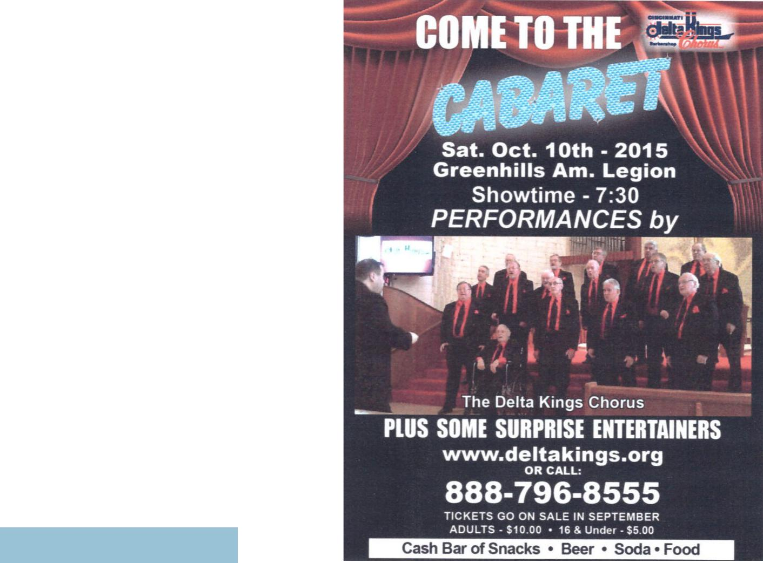

12

DX Spots—October 2015 de KA3MTT

Sun | Mon | Tue | Wed | Thu | Fri | Sat
 |  |  |  | 1 | 2 | 3
 |  |  |  | VP2M-Montserrat | TX3X - Chesterfield | S79SP - Seychelles
 |  |  |  | thru 10-8 | Isl thru 10-12 | thru 10-18
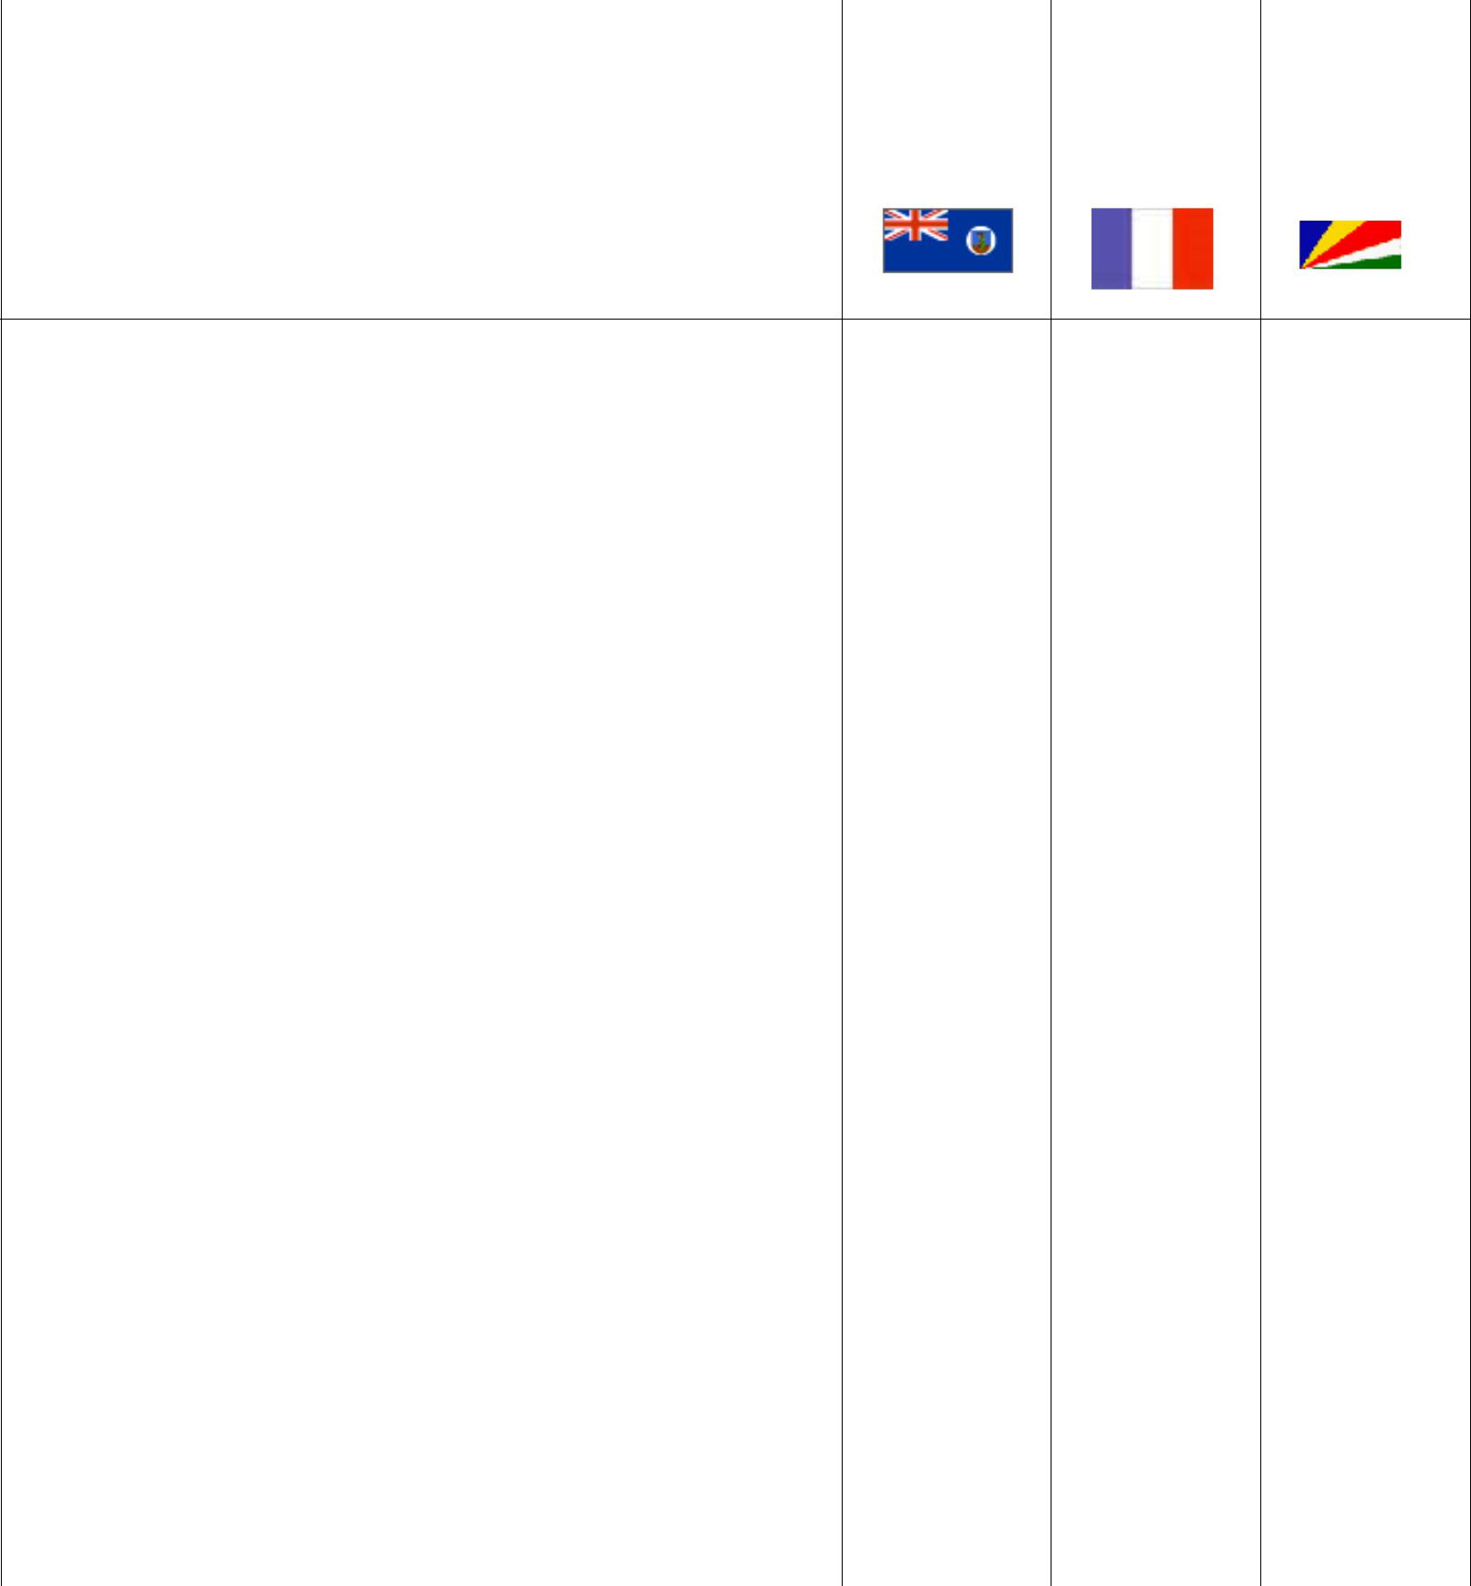

4 | 5 | 6 | 7 | 8 | 9 | 10
SV9-Crete thru 10-10 | 3B8-Mauritius thru | T88MZ - Palau thru | J6 - St Lucia thru |  | KG4 - Guantanamo
 | 10-20 | 10-9 | 10-18 |  | Bay thru 10-23
 |  | -----------------------
 |  | V47JA - St Kitts &
 |  | Nevis thru 11-6

11 | 12 | 13 | 14 | 15 | 16 | 17
TA3 - Turkey thru |  | V73D - Marshall Is |  |  | 3W2HCM - Vietnam | D4D-Cape Verde thru
10-30 |  | Thru 10-28 |  |  | Thru 10-23 | 10-24
 |  |  |  |  | ----------------------- | -------------------------
 |  |  |  |  | XX9 - Macao thru | PY0F-Fernando de
 |  |  |  |  | 10-28 | Noronha thru 10-27
 |  |  |  |  |  | ------------------------
 |  |  |  |  |  | 5J0B-San Andres &
 |  |  |  |  |  | Providencia thru
 |  |  |  |  |  | 10-27
18 | 19 | 20 | 21 | 22 | 23 | 24
V6 - Micronesia | PJ2 - Curacao thru |  | T42US - Cuba thru |  |  | 6Y5 - Jamaica thru
Thru 11-10 | 10-27 |  | 10-28 |  |  | 12-9

25 | 26 | 27 | 28 | 29 | 30 | 31
 | 3B7FA - Agalega & | T32DX - East Kiribati |  |  | T88 - Palau thru 11-5
 | St Brandon thru | Thru 11-3
 | 10-31
 | -----------------------
 | HI7 - Dominican
 | Republic thru 10-31

13

OH-KY-IN Amateur Radio Society

Regular monthly meetings are held the first Tuesday of each month at 7:30PM local time at the St Bernard Recreation Hall, 120 Washington Avenue (corner Washington & Tower Aves) in St Bernard, just east of Vine St. Please come in the doors at street level, facing the high school. Visitors are ALWAYS welcome!

.
The next meeting of the Oh-Ky-In Amateur Radio Society will be Tuesday, October 6th at 7:30 PM

Bill Curtice - WA8APB (Miami Valley Mesh Alliance) & Fred Stone - W8LLY (Greene County ARES Emergency Coordinator) will be giving a presentation on Ham Mesh networking. Be sure to bring paper and pens to take notes; You won't want to miss this.

OH-KY-IN Amateur Radio | PLEASE
Society | PLACE
 | STAMP
Q-FIVER Editor | HERE
Brian DeYoung, K4BRI
6901 Backus Drive
Alexandria, KY 41001
Phone: (859) 635-3095
Web: www.ohkyin.org
E-mail: k4bri@arrl.net
