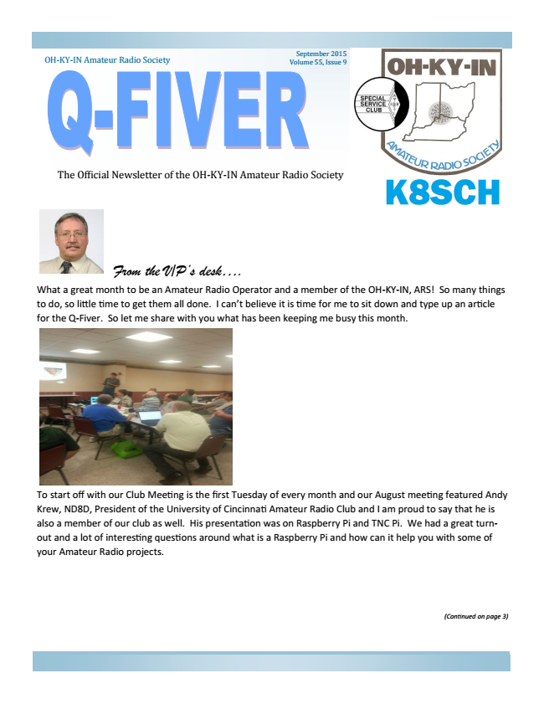

From the V/P’s desk....
What a great month to be an Amateur Radio Operator and a member of the OH-KY-IN, ARS! So many things to do, so little time to get them all done. I can’t believe it is time for me to sit down and type up an article for the Q-Fiver. So let me share with you what has been keeping me busy this month.
To start off with our Club Meeting is the first Tuesday of every month and our August meeting featured Andy Krew, ND8D, President of the University of Cincinnati Amateur Radio Club and I am proud to say that he is also a member of our club as well. His presentation was on Raspberry Pi and TNC Pi. We had a great turn- out and a lot of interesting questions around what is a Raspberry Pi and how can it help you with some of your Amateur Radio projects.
(Confinued on page 3)
OH-KY-IN Amateur Radio Society
The Official Newsletter of the OH-KY-IN Amateur Radio Society
September 2015 Volume 55, Issue 9

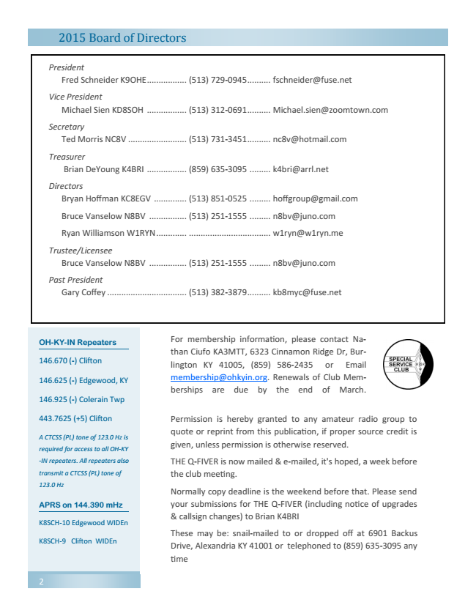

OH-KY-IN Repeaters
146.670 (-) Clifton
146.625 (-) Edgewood, KY
146.925 (-) Colerain Twp
443.7625 (+5) Clifton
A CTCSS (PL) tone of 123.0 Hz is
required for access to all OH-KY
-IN repeaters. All repeaters also
transmit a CTCSS (PL) tone of
123.0 Hz
APRS on 144.390 mHz
K8SCH-10 Edgewood WIDEn
K8SCH-9 Clifton WIDEn
2
2015 Board of Directors
President
Fred Schneider K9OHE ................. (513) 729-0945 .......... fschneider@fuse.net
Vice President
Michael Sien KD8SOH ................. (513) 312-0691 .......... Michael.sien@zoomtown.com
Secretary
Ted Morris NC8V ......................... (513) 731-3451 .......... nc8v@hotmail.com
Treasurer
Brian DeYoung K4BRI ................. (859) 635-3095 ......... k4bri@arrl.net
Directors
Bryan Hoffman KC8EGV .............. (513) 851-0525 ......... hoffgroup@gmail.com
Bruce Vanselow N8BV ................ (513) 251-1555 ......... n8bv@juno.com
Ryan Williamson W1RYN ............. ................................... w1ryn@w1ryn.me
Trustee/Licensee
Bruce Vanselow N8BV ................ (513) 251-1555 ......... n8bv@juno.com
Past President
Gary Coffey .................................. (513) 382-3879 .......... kb8myc@fuse.net
For membership information, please contact Na- than Ciufo KA3MTT, 6323 Cinnamon Ridge Dr, Bur- lington KY 41005, (859) 586-2435 or Email membership@ohkyin.org. Renewals of Club Mem- berships are due by the end of March.
Permission is hereby granted to any amateur radio group to quote or reprint from this publication, if proper source credit is given, unless permission is otherwise reserved.
THE Q-FIVER is now mailed & e-mailed, it's hoped, a week before the club meeting.
Normally copy deadline is the weekend before that. Please send your submissions for THE Q-FIVER (including notice of upgrades & callsign changes) to Brian K4BRI
These may be: snail-mailed to or dropped off at 6901 Backus Drive, Alexandria KY 41001 or telephoned to (859) 635-3095 any time

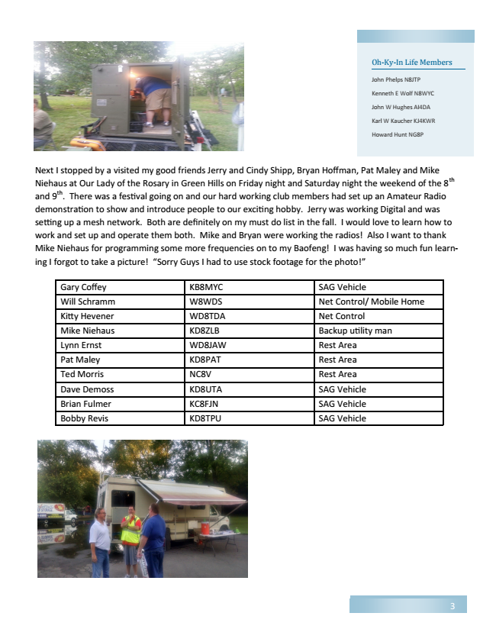

Next I stopped by a visited my good friends Jerry and Cindy Shipp, Bryan Hoffman, Pat Maley and Mike Niehaus at Our Lady of the Rosary in Green Hills on Friday night and Saturday night the weekend of the 8th and 9th. There was a festival going on and our hard working club members had set up an Amateur Radio demonstration to show and introduce people to our exciting hobby. Jerry was working Digital and was setting up a mesh network. Both are definitely on my must do list in the fall. I would love to learn how to work and set up and operate them both. Mike and Bryan were working the radios! Also I want to thank Mike Niehaus for programming some more frequencies on to my Baofeng! I was having so much fun learn- ing I forgot to take a picture! “Sorry Guys I had to use stock footage for the photo!”
Oh-Ky-In Life Members
John Phelps N8JTP
Kenneth E Wolf N8WYC
John W Hughes AI4DA
Karl W Kaucher KJ4KWR
Howard Hunt NG8P
Gary Coffey KB8MYC SAG Vehicle Will Schramm W8WDS Net Control/ Mobile Home Kitty Hevener WD8TDA Net Control Mike Niehaus KD8ZLB Backup utility man Lynn Ernst WD8JAW Rest Area Pat Maley KD8PAT Rest Area Ted Morris NC8V Rest Area Dave Demoss KD8UTA SAG Vehicle Brian Fulmer KC8FJN SAG Vehicle Bobby Revis KD8TPU SAG Vehicle
3

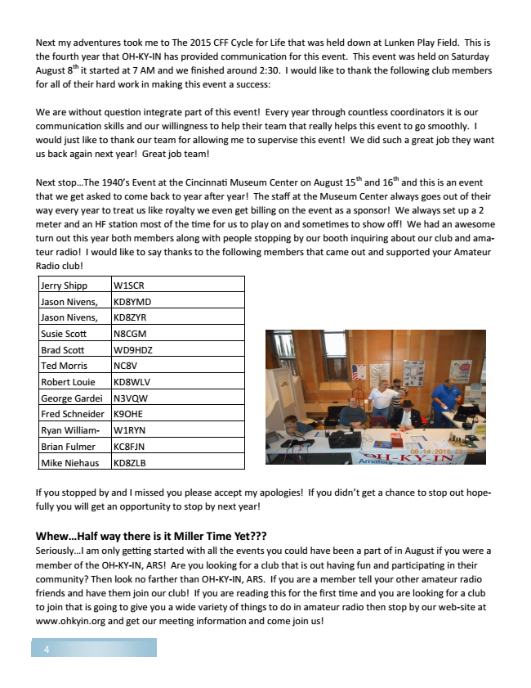

Next my adventures took me to The 2015 CFF Cycle for Life that was held down at Lunken Play Field. This is the fourth year that OH-KY-IN has provided communication for this event. This event was held on Saturday August 8
th
it started at 7 AM and we finished around 2:30. I would like to thank the following club members for all of their hard work in making this event a success:
We are without question integrate part of this event! Every year through countless coordinators it is our communication skills and our willingness to help their team that really helps this event to go smoothly. I would just like to thank our team for allowing me to supervise this event! We did such a great job they want us back again next year! Great job team!
Next stop...The 1940’s Event at the Cincinnati Museum Center on August 15th and 16th and this is an event that we get asked to come back to year after year! The staff at the Museum Center always goes out of their way every year to treat us like royalty we even get billing on the event as a sponsor! We always set up a 2 meter and an HF station most of the time for us to play on and sometimes to show off! We had an awesome turn out this year both members along with people stopping by our booth inquiring about our club and ama- teur radio! I would like to say thanks to the following members that came out and supported your Amateur Radio club!
Jerry Shipp W1SCR Jason Nivens, KD8YMD Jason Nivens, KD8ZYR Susie Scott N8CGM Brad Scott WD9HDZ Ted Morris NC8V Robert Louie KD8WLV George Gardei N3VQW Fred Schneider K9OHE Ryan William- W1RYN Brian Fulmer KC8FJN Mike Niehaus KD8ZLB
If you stopped by and I missed you please accept my apologies! If you didn’t get a chance to stop out hope- fully you will get an opportunity to stop by next year!
Whew...Half way there is it Miller Time Yet??? Seriously...I am only getting started with all the events you could have been a part of in August if you were a member of the OH-KY-IN, ARS! Are you looking for a club that is out having fun and participating in their community? Then look no farther than OH-KY-IN, ARS. If you are a member tell your other amateur radio friends and have them join our club! If you are reading this for the first time and you are looking for a club to join that is going to give you a wide variety of things to do in amateur radio then stop by our web-site at www.ohkyin.org and get our meeting information and come join us!
4

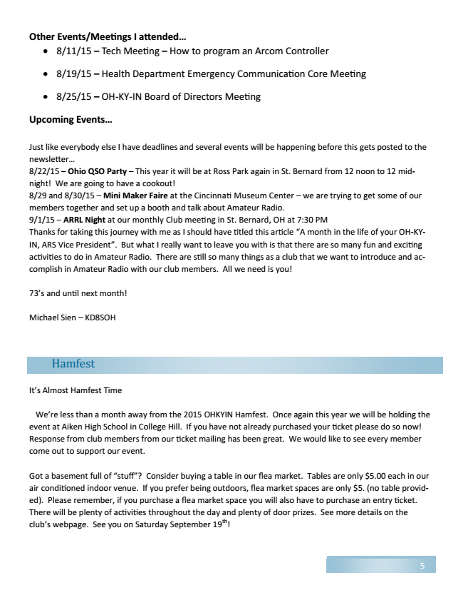

Other Events/Meetings I attended...
• 8/11/15 – Tech Meeting – How to program an Arcom Controller
• 8/19/15 – Health Department Emergency Communication Core Meeting
• 8/25/15 – OH-KY-IN Board of Directors Meeting
Upcoming Events...
Just like everybody else I have deadlines and several events will be happening before this gets posted to the newsletter... 8/22/15 – Ohio QSO Party – This year it will be at Ross Park again in St. Bernard from 12 noon to 12 mid- night! We are going to have a cookout! 8/29 and 8/30/15 – Mini Maker Faire at the Cincinnati Museum Center – we are trying to get some of our members together and set up a booth and talk about Amateur Radio. 9/1/15 – ARRL Night at our monthly Club meeting in St. Bernard, OH at 7:30 PM Thanks for taking this journey with me as I should have titled this article “A month in the life of your OH-KY- IN, ARS Vice President”. But what I really want to leave you with is that there are so many fun and exciting activities to do in Amateur Radio. There are still so many things as a club that we want to introduce and ac- complish in Amateur Radio with our club members. All we need is you!
73’s and until next month!
Michael Sien – KD8SOH
Hamfest
It’s Almost Hamfest Time
We’re less than a month away from the 2015 OHKYIN Hamfest. Once again this year we will be holding the event at Aiken High School in College Hill. If you have not already purchased your ticket please do so now! Response from club members from our ticket mailing has been great. We would like to see every member come out to support our event.
Got a basement full of “stuff”? Consider buying a table in our flea market. Tables are only $5.00 each in our air conditioned indoor venue. If you prefer being outdoors, flea market spaces are only $5. (no table provid- ed). Please remember, if you purchase a flea market space you will also have to purchase an entry ticket. There will be plenty of activities throughout the day and plenty of door prizes. See more details on the club’s webpage. See you on Saturday September 19th!
5

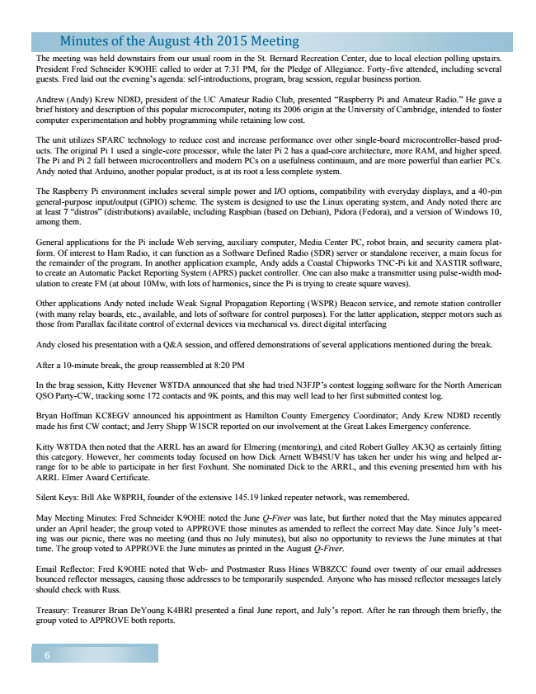

Minutes of the August 4th 2015 Meeting
The meeting was held downstairs from our usual room in the St. Bernard Recreation Center, due to local election polling upstairs. President Fred Schneider K9OHE called to order at 7:31 PM, for the Pledge of Allegiance. Forty-five attended, including several guests. Fred laid out the evening’s agenda: self-introductions, program, brag session, regular business portion.
Andrew (Andy) Krew ND8D, president of the UC Amateur Radio Club, presented “Raspberry Pi and Amateur Radio.” He gave a brief history and description of this popular microcomputer, noting its 2006 origin at the University of Cambridge, intended to foster computer experimentation and hobby programming while retaining low cost.
The unit utilizes SPARC technology to reduce cost and increase performance over other single-board microcontroller-based prod- ucts. The original Pi 1 used a single-core processor, while the later Pi 2 has a quad-core architecture, more RAM, and higher speed. The Pi and Pi 2 fall between microcontrollers and modern PCs on a usefulness continuum, and are more powerful than earlier PCs. Andy noted that Arduino, another popular product, is at its root a less complete system.
The Raspberry Pi environment includes several simple power and I/O options, compatibility with everyday displays, and a 40-pin general-purpose input/output (GPIO) scheme. The system is designed to use the Linux operating system, and Andy noted there are at least 7 “distros” (distributions) available, including Raspbian (based on Debian), Pidora (Fedora), and a version of Windows 10, among them.
General applications for the Pi include Web serving, auxiliary computer, Media Center PC, robot brain, and security camera plat- form. Of interest to Ham Radio, it can function as a Software Defined Radio (SDR) server or standalone receiver, a main focus for the remainder of the program. In another application example, Andy adds a Coastal Chipworks TNC-Pi kit and XASTIR software, to create an Automatic Packet Reporting System (APRS) packet controller. One can also make a transmitter using pulse-width mod- ulation to create FM (at about 10Mw, with lots of harmonics, since the Pi is trying to create square waves).
Other applications Andy noted include Weak Signal Propagation Reporting (WSPR) Beacon service, and remote station controller (with many relay boards, etc., available, and lots of software for control purposes). For the latter application, stepper motors such as those from Parallax facilitate control of external devices via mechanical vs. direct digital interfacing
Andy closed his presentation with a Q&A session, and offered demonstrations of several applications mentioned during the break.
After a 10-minute break, the group reassembled at 8:20 PM
In the brag session, Kitty Hevener W8TDA announced that she had tried N3FJP’s contest logging software for the North American QSO Party-CW, tracking some 172 contacts and 9K points, and this may well lead to her first submitted contest log.
Bryan Hoffman KC8EGV announced his appointment as Hamilton County Emergency Coordinator; Andy Krew ND8D recently made his first CW contact; and Jerry Shipp W1SCR reported on our involvement at the Great Lakes Emergency conference.
Kitty W8TDA then noted that the ARRL has an award for Elmering (mentoring), and cited Robert Gulley AK3Q as certainly fitting this category. However, her comments today focused on how Dick Arnett WB4SUV has taken her under his wing and helped ar- range for to be able to participate in her first Foxhunt. She nominated Dick to the ARRL, and this evening presented him with his ARRL Elmer Award Certificate.
Silent Keys: Bill Ake W8PRH, founder of the extensive 145.19 linked repeater network, was remembered.
May Meeting Minutes: Fred Schneider K9OHE noted the June Q-Fiver was late, but further noted that the May minutes appeared under an April header; the group voted to APPROVE those minutes as amended to reflect the correct May date. Since July’s meet- ing was our picnic, there was no meeting (and thus no July minutes), but also no opportunity to reviews the June minutes at that time. The group voted to APPROVE the June minutes as printed in the August Q-Fiver.
Email Reflector: Fred K9OHE noted that Web- and Postmaster Russ Hines WB8ZCC found over twenty of our email addresses bounced reflector messages, causing those addresses to be temporarily suspended. Anyone who has missed reflector messages lately should check with Russ.
Treasury: Treasurer Brian DeYoung K4BRI presented a final June report, and July’s report. After he ran through them briefly, the group voted to APPROVE both reports.
6

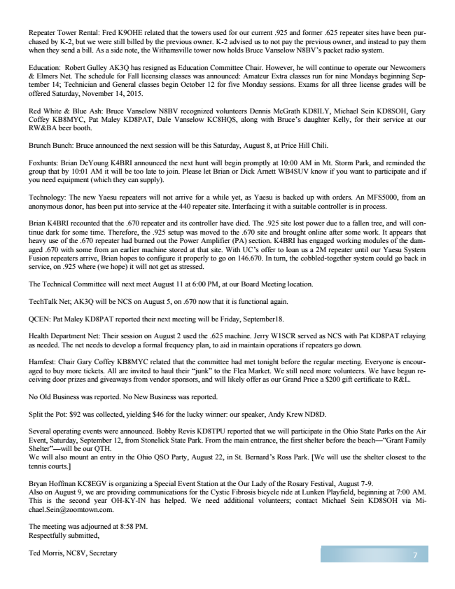

Repeater Tower Rental: Fred K9OHE related that the towers used for our current .925 and former .625 repeater sites have been pur- chased by K-2, but we were still billed by the previous owner. K-2 advised us to not pay the previous owner, and instead to pay them when they send a bill. As a side note, the Withamsville tower now holds Bruce Vanselow N8BV’s packet radio system.
Education: Robert Gulley AK3Q has resigned as Education Committee Chair. However, he will continue to operate our Newcomers & Elmers Net. The schedule for Fall licensing classes was announced: Amateur Extra classes run for nine Mondays beginning Sep- tember 14; Technician and General classes begin October 12 for five Monday sessions. Exams for all three license grades will be offered Saturday, November 14, 2015.
Red White & Blue Ash: Bruce Vanselow N8BV recognized volunteers Dennis McGrath KD8ILY, Michael Sein KD8SOH, Gary Coffey KB8MYC, Pat Maley KD8PAT, Dale Vanselow KC8HQS, along with Bruce’s daughter Kelly, for their service at our RW&BA beer booth.
Brunch Bunch: Bruce announced the next session will be this Saturday, August 8, at Price Hill Chili.
Foxhunts: Brian DeYoung K4BRI announced the next hunt will begin promptly at 10:00 AM in Mt. Storm Park, and reminded the group that by 10:01 AM it will be too late to join. Please let Brian or Dick Arnett WB4SUV know if you want to participate and if you need equipment (which they can supply).
Technology: The new Yaesu repeaters will not arrive for a while yet, as Yaesu is backed up with orders. An MFS5000, from an anonymous donor, has been put into service at the 440 repeater site. Interfacing it with a suitable controller is in process.
Brian K4BRI recounted that the .670 repeater and its controller have died. The .925 site lost power due to a fallen tree, and will con- tinue dark for some time. Therefore, the .925 setup was moved to the .670 site and brought online after some work. It appears that heavy use of the .670 repeater had burned out the Power Amplifier (PA) section. K4BRI has engaged working modules of the dam- aged .670 with some from an earlier machine stored at that site. With UC’s offer to loan us a 2M repeater until our Yaesu System Fusion repeaters arrive, Brian hopes to configure it properly to go on 146.670. In turn, the cobbled-together system could go back in service, on .925 where (we hope) it will not get as stressed.
The Technical Committee will next meet August 11 at 6:00 PM, at our Board Meeting location.
TechTalk Net; AK3Q will be NCS on August 5, on .670 now that it is functional again.
QCEN: Pat Maley KD8PAT reported their next meeting will be Friday, September18.
Health Department Net: Their session on August 2 used the .625 machine. Jerry W1SCR served as NCS with Pat KD8PAT relaying as needed. The net needs to develop a formal frequency plan, to aid in maintain operations if repeaters go down.
Hamfest: Chair Gary Coffey KB8MYC related that the committee had met tonight before the regular meeting. Everyone is encour- aged to buy more tickets. All are invited to haul their “junk” to the Flea Market. We still need more volunteers. We have begun re- ceiving door prizes and giveaways from vendor sponsors, and will likely offer as our Grand Price a $200 gift certificate to R&L.
No Old Business was reported. No New Business was reported.
Split the Pot: $92 was collected, yielding $46 for the lucky winner: our speaker, Andy Krew ND8D.
Several operating events were announced. Bobby Revis KD8TPU reported that we will participate in the Ohio State Parks on the Air Event, Saturday, September 12, from Stonelick State Park. From the main entrance, the first shelter before the beach—“Grant Family Shelter”—will be our QTH. We will also mount an entry in the Ohio QSO Party, August 22, in St. Bernard’s Ross Park. [We will use the shelter closest to the tennis courts.]
Bryan Hoffman KC8EGV is organizing a Special Event Station at the Our Lady of the Rosary Festival, August 7-9. Also on August 9, we are providing communications for the Cystic Fibrosis bicycle ride at Lunken Playfield, beginning at 7:00 AM. This is the second year OH-KY-IN has helped. We need additional volunteers; contact Michael Sein KD8SOH via Mi- chael.Sein@zoomtown.com.
The meeting was adjourned at 8:58 PM. Respectfully submitted,
Ted Morris, NC8V, Secretary
7

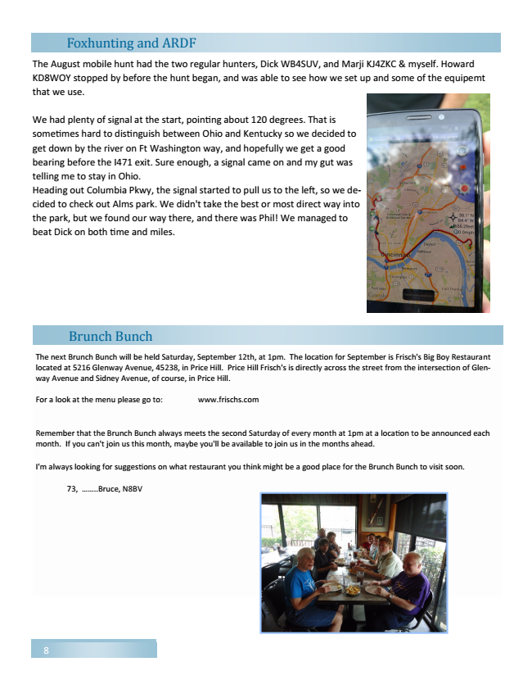

Foxhunting and ARDF
The August mobile hunt had the two regular hunters, Dick WB4SUV, and Marji KJ4ZKC & myself. Howard KD8WOY stopped by before the hunt began, and was able to see how we set up and some of the equipemt that we use.
We had plenty of signal at the start, pointing about 120 degrees. That is sometimes hard to distinguish between Ohio and Kentucky so we decided to get down by the river on Ft Washington way, and hopefully we get a good bearing before the I471 exit. Sure enough, a signal came on and my gut was telling me to stay in Ohio. Heading out Columbia Pkwy, the signal started to pull us to the left, so we de- cided to check out Alms park. We didn't take the best or most direct way into the park, but we found our way there, and there was Phil! We managed to beat Dick on both time and miles.
Brunch Bunch
The next Brunch Bunch will be held Saturday, September 12th, at 1pm. The location for September is Frisch's Big Boy Restaurant located at 5216 Glenway Avenue, 45238, in Price Hill. Price Hill Frisch's is directly across the street from the intersection of Glen- way Avenue and Sidney Avenue, of course, in Price Hill.
For a look at the menu please go to: www.frischs.com
Remember that the Brunch Bunch always meets the second Saturday of every month at 1pm at a location to be announced each month. If you can't join us this month, maybe you'll be available to join us in the months ahead.
I'm always looking for suggestions on what restaurant you think might be a good place for the Brunch Bunch to visit soon.
73, ........Bruce, N8BV
8

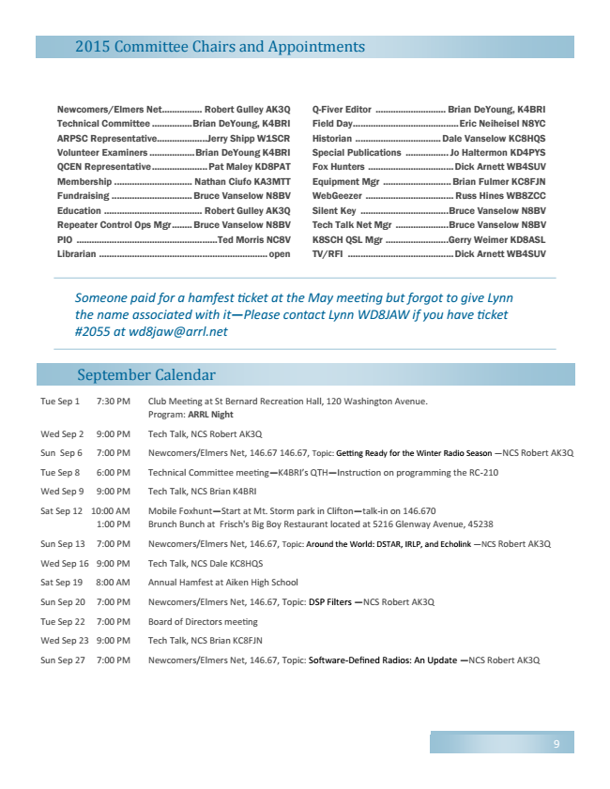

2015 Committee Chairs and Appointments
Newcomers/Elmers Net ................ Robert Gulley AK3Q Technical Committee ................ Brian DeYoung, K4BRI ARPSC Representative ....................Jerry Shipp W1SCR Volunteer Examiners .................. Brian DeYoung K4BRI QCEN Representative ...................... Pat Maley KD8PAT Membership ............................... Nathan Ciufo KA3MTT Fundraising ................................ Bruce Vanselow N8BV Education ....................................... Robert Gulley AK3Q Repeater Control Ops Mgr ........ Bruce Vanselow N8BV PIO ........................................................ Ted Morris NC8V Librarian ................................................................... open
September Calendar
Q-Fiver Editor ............................ Brian DeYoung, K4BRI Field Day .......................................... Eric Neiheisel N8YC Historian .................................. Dale Vanselow KC8HQS Special Publications ................. Jo Haltermon KD4PYS Fox Hunters .................................. Dick Arnett WB4SUV Equipment Mgr ........................... Brian Fulmer KC8FJN WebGeezer ................................... Russ Hines WB8ZCC Silent Key ................................... Bruce Vanselow N8BV Tech Talk Net Mgr ..................... Bruce Vanselow N8BV K8SCH QSL Mgr .........................Gerry Weimer KD8ASL TV/RFI .......................................... Dick Arnett WB4SUV
Someone paid for a hamfest ficket at the May meefing but forgot to give Lynn the name associated with it—Please contact Lynn WD8JAW if you have ficket #2055 at wd8jaw@arrl.net
Tue Sep 1 7:30 PM Club Meeting at St Bernard Recreation Hall, 120 Washington Avenue.
Program: ARRL Night
Wed Sep 2 9:00 PM Tech Talk, NCS Robert AK3Q
Sun Sep 6 7:00 PM Newcomers/Elmers Net, 146.67 146.67, Topic: Getting Ready for the Winter Radio Season —NCS Robert AK3Q
Tue Sep 8 6:00 PM Technical Committee meeting—K4BRI’s QTH—Instruction on programming the RC-210
Wed Sep 9 9:00 PM Tech Talk, NCS Brian K4BRI
Sat Sep 12 10:00 AM Mobile Foxhunt—Start at Mt. Storm park in Clifton—talk-in on 146.670
1:00 PM Brunch Bunch at Frisch's Big Boy Restaurant located at 5216 Glenway Avenue, 45238
Sun Sep 13 7:00 PM Newcomers/Elmers Net, 146.67, Topic: Around the World: DSTAR, IRLP, and Echolink —NCS Robert AK3Q
Wed Sep 16 9:00 PM Tech Talk, NCS Dale KC8HQS
Sat Sep 19 8:00 AM Annual Hamfest at Aiken High School
Sun Sep 20 7:00 PM Newcomers/Elmers Net, 146.67, Topic: DSP Filters —NCS Robert AK3Q
Tue Sep 22 7:00 PM Board of Directors meeting
Wed Sep 23 9:00 PM Tech Talk, NCS Brian KC8FJN
Sun Sep 27 7:00 PM Newcomers/Elmers Net, 146.67, Topic: Software-Defined Radios: An Update —NCS Robert AK3Q
9

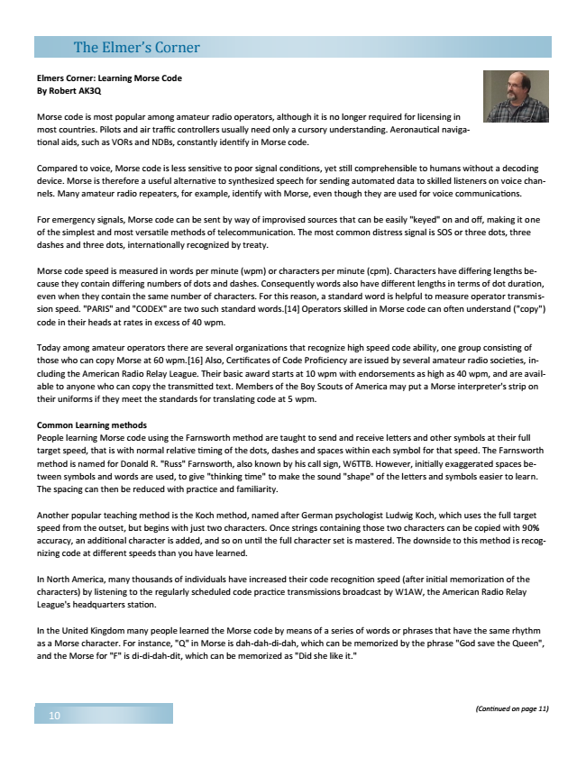

Elmers Corner: Learning Morse Code By Robert AK3Q
Morse code is most popular among amateur radio operators, although it is no longer required for licensing in most countries. Pilots and air traffic controllers usually need only a cursory understanding. Aeronautical naviga- tional aids, such as VORs and NDBs, constantly identify in Morse code.
Compared to voice, Morse code is less sensitive to poor signal conditions, yet still comprehensible to humans without a decoding device. Morse is therefore a useful alternative to synthesized speech for sending automated data to skilled listeners on voice chan- nels. Many amateur radio repeaters, for example, identify with Morse, even though they are used for voice communications.
For emergency signals, Morse code can be sent by way of improvised sources that can be easily "keyed" on and off, making it one of the simplest and most versatile methods of telecommunication. The most common distress signal is SOS or three dots, three dashes and three dots, internationally recognized by treaty.
Morse code speed is measured in words per minute (wpm) or characters per minute (cpm). Characters have differing lengths be- cause they contain differing numbers of dots and dashes. Consequently words also have different lengths in terms of dot duration, even when they contain the same number of characters. For this reason, a standard word is helpful to measure operator transmis- sion speed. "PARIS" and "CODEX" are two such standard words.[14] Operators skilled in Morse code can often understand ("copy") code in their heads at rates in excess of 40 wpm.
Today among amateur operators there are several organizations that recognize high speed code ability, one group consisting of those who can copy Morse at 60 wpm.[16] Also, Certificates of Code Proficiency are issued by several amateur radio societies, in- cluding the American Radio Relay League. Their basic award starts at 10 wpm with endorsements as high as 40 wpm, and are avail- able to anyone who can copy the transmitted text. Members of the Boy Scouts of America may put a Morse interpreter's strip on their uniforms if they meet the standards for translating code at 5 wpm.
Common Learning methods People learning Morse code using the Farnsworth method are taught to send and receive letters and other symbols at their full target speed, that is with normal relative timing of the dots, dashes and spaces within each symbol for that speed. The Farnsworth method is named for Donald R. "Russ" Farnsworth, also known by his call sign, W6TTB. However, initially exaggerated spaces be- tween symbols and words are used, to give "thinking time" to make the sound "shape" of the letters and symbols easier to learn. The spacing can then be reduced with practice and familiarity.
Another popular teaching method is the Koch method, named after German psychologist Ludwig Koch, which uses the full target speed from the outset, but begins with just two characters. Once strings containing those two characters can be copied with 90% accuracy, an additional character is added, and so on until the full character set is mastered. The downside to this method is recog- nizing code at different speeds than you have learned.
In North America, many thousands of individuals have increased their code recognition speed (after initial memorization of the characters) by listening to the regularly scheduled code practice transmissions broadcast by W1AW, the American Radio Relay League's headquarters station.
In the United Kingdom many people learned the Morse code by means of a series of words or phrases that have the same rhythm as a Morse character. For instance, "Q" in Morse is dah-dah-di-dah, which can be memorized by the phrase "God save the Queen", and the Morse for "F" is di-di-dah-dit, which can be memorized as "Did she like it."
10
(Confinued on page 11)
The Elmerss Corner

