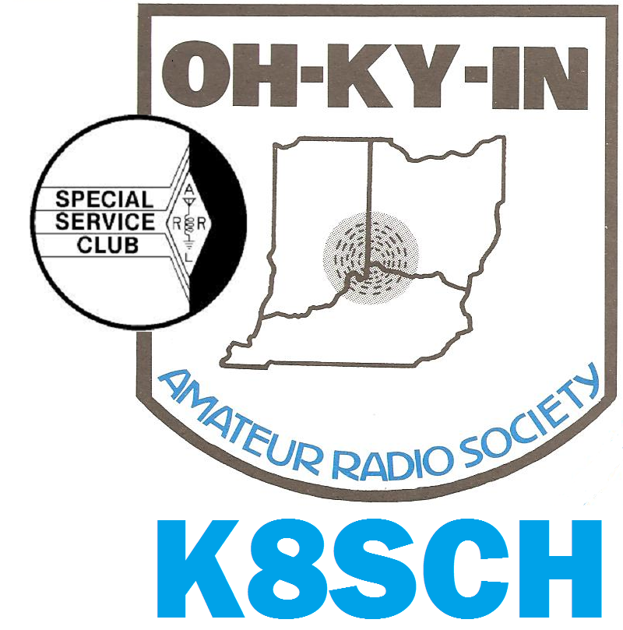
Q-Fiver

Official Newsletter of the OH-KY-IN Amateur Radio Society

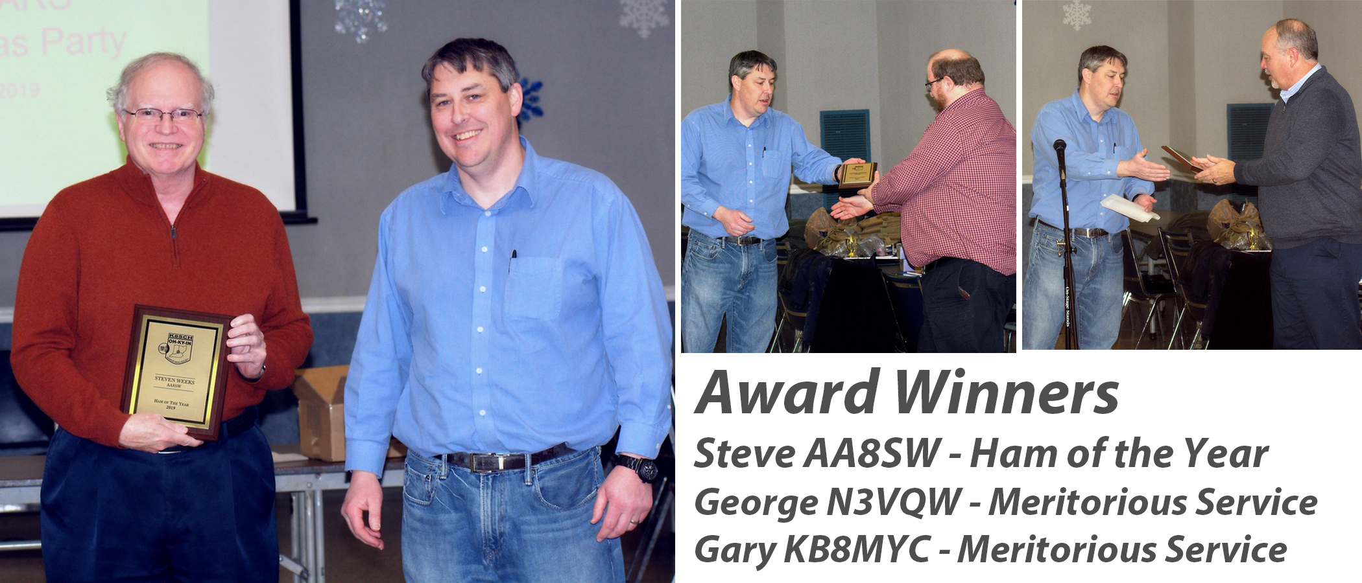
In The News  Achievement Awards  Congrats to Steve (AA8SW) for being voted Ham of the Year! Steve has worked behind the scenes and right out front for the club, as well as amassing a staggering number of contacts in ~2 years of operating, over 26,000 (yes, that’s right!)  (Continued inside) | In The News  Officers Elected  Ryan (AC8UJ) – President  Cesi (KD8OOB) – VP  George N3VQW – Sec.  Brian (K4BRI) Treasurer  Bruce (N8BV) Dir./Trustee  Dennis (KD8ILY) Dir.  Mike (KD8ZLB) Dir. |  | In The News  Club Christmas Party  Lots of great prizes, great food (pizza, sides, tons of desserts!), and a great way to end the year!  In addition to the club-purchased prizes, there were many door prizes contributed by folks, and they just added to the fun!

Awards cont. from Page 1

S

teve has achieved this extraodinary number of contacts due in part to the grid chase competition of 2018, in which he placed a phenomonal score within the top 100 operators in the world among some ~46,000 participants!! (This in his first year of being a licensed operator!)

Steve has continued to rack up impressive numbers this year not only with FT4 and FT8 work, but also adding RTTY and CW to his list of active modes, as well as SSB as conditions allow.

Steve also volunteered his legal expertise in reviewing/modifying the society’s Bylaws & Constitution for adoption by the club. Additionally, he has been lending a hand with the Technical committee.

Finally, Steve has been contributing to the educational emphasis of the club both by creating and posting an Amateur Radio General License Question/Answer Study Guide on the club’s Web Site, and joining the team of teachers for OHKYIN Licensing classes.

Well done Steve!!!

G

ary (KB8MYC) was honored with a well-deserved Meritorious Service Award for his many activities in the club, but especially for his work successfully heading up the Hamfest Committee for the last 5 years. Not only have the Hamfests raised income and awareness of the club, but these have also been great opportunities to meet other hams in person!

Gary has also been recognized for stepping up to chair the Technical Committee, which as we all know, has been quite a challenge this year! Our repeaters have been quite cantankerous, requiring many trips back and forth to keep things on the air!

Well done Gary!!!
G
eorge (N3VQW) also won a Meritorious Service Award for his work as Secretary for the club, and for numerous club events which he organized or in which he participated. Without George stepping up several events would never have happened, so George, we thank you!
Well done George!!!

Tips and Tricks
Thanks to John Major (KD8MMY) for our first Tip:
A Baofeng HT was on my hip when I pressed door lock button on door handle when getting out of car. Heard static on HT and looked and display was dead. Some type RFI from the car solenoid may have caused this. Tried re-powering and replacing with a known good battery. Still “dead”.
Later I decided to use the bad HT just to charge a spare battery. When I put it in the charger, the display then worked, and all programming was still there.
Possible fix was due to the charge voltage of the charger being higher than the battery itself, and somehow was needed to clear/reset unit to normal. It is still working.
Certainly a strange problem, but hopefully this tip could help others if an HT goes into a dead state.
(send in your tips and tricks to my E-mail address – who knows whom you’ll help! – Editor)

Where is TechTalk???
For the last few weeks, the TechTalk net has been held on the 147.240 (+) PL123 repeater operated by the Queen City Emergency Net. The 442.700 (+) PL123 repeater has been linked during the net as well. Even if you don't have any questions for the net, you just might have the answer to someone else's question. And you'll get updated with what is going on in the amateur radio world by listening in to both the Amateur Radio Newsline and Amateur News Weekly amateur radio news reports. The TechTalk net is held every Wednesday night at 9pm.
TechTalk will continue to be held on the QCEN repeaters until the controller at the 146.670 repeater is returned to service.
A big thank you goes out to the Queen City Emergency Net for allowing us to hold TechTalk on their repeaters.
73, Bruce N8BV, TechTalk Net Manager

President
Ryan Owens AC8UJ (513) 235-0134 ac8uj@arrl.net

Board of Directors

Vice President
Cesi DiBenedetto KD8OOB (513) 505-9782 kd8oob@gmail.com
Secretary
George Gardei N3VQW (513) 410-3406 george@gardeitech.com
Treasurer
Brian DeYoung K4BRI (859) 635-3095 k4bri@arrl.net
Directors
Bruce Vanselow N8BV (513) 251-1555 n8bvbruce@gmail.com
Mike Niehaus KD8ZLB (513) 257-6013 kd8zlb@gmail.com
Dennis McGrath KD8ILY (513) 207-9472 mcgratd@yahoo.com
Trustee/Licensee
Bruce Vanselow N8BV (513) 251-1555 n8bvbruce@gmail.com

OH-KY-IN Repeaters

146.670 (-) Clifton 146.625 *(-) Edgewood 146.925 *(-) Delhi
443.7625 *(+5) Clifton [(*) Indicates Fusion Repeater]
A CTCSS (PL) tone of 123.0 Hz is required for access to all OH-KY-IN repeaters.
All repeaters also transmit a CTCSS (PL) tone of 123.0 Hz
APRS on 144.390 MHz K8SCH-10 Edgewood WIDEn
Packet on 145.010 MHz K8SCH-7 Digipeater
For membership information, please contact Nathan Ciufo KA3MTT, 6323 Cinnamon Ridge Dr, Burlington KY 41005, (859) 586-2435 or
Email membership@ohkyin.org.
Renewals of Club Memberships are due by the end of March. Please remember to indicate any changes to your contact information on your renewal!

2020 Committee Chairs and Appointments
Technical Operations Group  ARPSC Representative  Volunteer Examiners  QCEN Representative  Membership  Fundraising  Education  Repeater Control Ops Mgr.  PIO  Librarian  Digital Group  Q-Fiver Editor  Field Day  Historian  Fox Hunters  Equipment Mgr.  WebMaster  Silent Key  Tech Talk Net Mgr.  K8SCH QSL Mgr.  TV/RFI  HamFest | Gary Coffey KB8MYC  Jerry Shipp W1SCR  Brian DeYoung K4BRI  Pat Maley KD8PAT  Nathan Ciufo KA3MTT  Bruce Vanselow N8BV  Michael Niehaus KD8ZLB  Bruce Vanselow N8BV  (Position Open)  Justin Moore KE8COY  Jerry Shipp W1SCR  Robert Gulley K4PKM  Eric Neiheisel N8YC  Dale Vanselow KC8HQS  Dick Arnett WB4SUV  (position open)  George Gardei N3VQW  Bryan Hoffman KC8EGV  Bruce Vanselow N8BV  Bob Frey WA6EZV  Dick Arnett WB4SUV  Gary Coffey KB8MYC

TechTalk Operators for January 2020

1st Wednesday Mike N8MRS
2nd Wednesday Mike N8MRS
3rd Wednesday Dale KC8HQS
4th Wednesday George N3VQW
5th Wednesday Rick KD4PYR

The Radiophonic Laboratory:
Teletouring Across the Time Zones with the Phone Fidelity Device
By Justin Patrick Moore, KE8COY
Most people who go to see underground music, myself included, are for the most part jaded about the music, the bands, the scene, man. If you’ve been around independent music long enough there is a good chance you’ve frequented the bars, basements and other performance spaces where these bands play. As such playing at these types of venues only reaches the damaged ear drums of those who would have been there anyway. The terminal music junkies and barflies eager to get their fix of distortion.
For bands who are interested in reaching a wider segment of the population and new audiences, going on tour isn’t necessarily the answer. Besides, for broke or struggling independent musicians, tours are costly and time consuming. Vans filled with a bunch of music freaks who haven’t bathed in a few days, and who get really sweaty on stage when playing the drums, get smelly. Especially when mixed with the smell of half-eaten, carry-out burritos. When the local hipsters don’t offer up a pad to crash at, the cost of motel rooms adds up, as do the buckets of Kentucky Fried Chicken that grease the wheels and keep the band on the road.
As an experiment in media and technology and as a way to get around these problems, the pioneering experimental music group Negativland created a phone fidelity device that allowed them to play live music from their home studio into their humble home telephone and broadcast the concert on radio stations all over North America and in England. The Teletour was born.
A radio audience is different from those found at the aforementioned hipster venues. They represent a much larger cross-section of the listening public and are a bit closer to the actual reality of the population. The Teletour allowed them to reach an audience who probably never would have stepped into a Negativland show or go to the places they play when they do perform on stage.
Their first series of broadcast telephone concerts known as the Teletour were performed over a period of two weeks in 1988. In total this consisted of about 20 one-hour concerts from their home studio into various community and college radio stations. Twenty concerts in two weeks provided a lot of exposure and entertainment to the audiences who heard them. Each of these concerts was transmitted with their homebrewed phone fidelity device. Negativland appeared on the air in about 20 cities, from points as distant as Hawaii and England, all while ensconced in their Bay Area studio.
The simple elegance of the idea was received with enthusiasm by the stations and their audiences. The motto for the Teletour was “From Our House to Yours,” and summed up all the attractions of bypassing the usual formulas for touring. Most bands touring in the traditional way would have a difficult time playing just one gig a day. Without having to tear down, set up and drive to the next city, a lot of the pressures exerted on touring bands were made moot. Although Negativland has continued to perform live in clubs and other venues (I got to see them at the Southgate House in 2006) the Teletour remains, even all these decades later, a fresh alternative to the over-beaten path of the tour van grind. The Teletour also complimented Negativland’s close relationship with radio work as discussed in last month’s article on their KPFA radio show Over the Edge. I do think the Teletour could be taken up by other musicians and radio stations today who want to continue exploring and refining the technique.
The magic of radio reaches into the unique personal space of the listener’s own environment. As such the Teletour is well suited to the kind of cerebral levels of thought and stream of consciousness associations evoked by Negativland and other electronic musicians who make heavy use of sampling. For the group, there was also something super appealing about their sounds being carried electrically over the phone and going out over a radio station in some places they may never have even visited in person, to be picked up by the unsuspecting ears of a random listener. This allowed for an element of real immediate and surprise and delight to occur for those who happened to tune across the dial and listen to a kind of radio and music they may have never heard before.
The Teletour also allowed Negativland to travel across vast distances at incredible speeds. They were able to jaunt between separate and isolated locations in short amounts of time. During the Teletour they were able to play several different time zones in the same evening. This way of touring also saved them money. The Teletours didn’t cost the band a dime while giving them exposure.
The rules they made for Teletouring were simple. Negativland played for free. The receiving radio station only had to pick up the tab for the long-distance phone call. Each show lasted about one hour. Negativland incorporated the station’s legal ID into the show so that concerts could continue uninterrupted. They also sent out posters to participating stations in advance to promote the broadcast.
All of this evolved from a bit of homebrewed tech that connected their studio mixer to a normal phone line and transmitted the sounds over the line with improved audio fidelity. Phone companies do rent out high-tech and high-fidelity lines for concert transmissions; these are, on the whole, prohibitively expensive for the kinds of musicians who also have to hold down day jobs. Negativland made their own version. This box was originally built by David Wills (the Weatherman) in connection with Negativland’s radio show, Over the Edge, as explored last month.
When the Weatherman wasn’t at the studio with Don Joyce, he would call in to the show. He soon cooked up a method for increasing the fidelity of his call into the station. Don Joyce realized that his phoned-in material had sharpness and clarity different from the other phoned-in material. The Weatherman had hooked the output of a small mixer up to his device, and then to his phone. This setup allowed him to send a variety of sources (cassettes, instruments, microphones, etc.) directly into the phone line with a significantly enhanced frequency range.
This phone fidelity device does not exactly produce high fidelity, but it does create a surprising improvement in highs and lows, and provides enough depth for effects such as reverb to work well.
Having built the phone fidelity device, the Weatherman spread the tech around to several of the other regular callers to OTE. The band eventually realized that it was a no-brainer to use this technology to perform over the phone at remote stations as a group. In 1987 they arranged the first experiment with a college station in British Columbia, and about a year later embarked on the first full-scale Teletour. Their record label at the time, SST, set up about 20 concerts at college stations all across the country occurring over a two-week period. They also arranged one concert for the BBC outlet in Sussex, England.
Negativland found the Teletour to be an entirely positive experience. Playing live anywhere in the world at the drop of a hat with few expenses seems like a great idea for independent bands, but for some reason it hasn’t caught on. If you would like to experiment with this little piece of empowering technology, the plans will be included in part two of this article in the February issue.
Negativland has freely distributed these for the past three decades. I think it is time for today’s independent musicians to coordinate some airtime with community and college or even shortwave radio stations, and bring the Teletour back to life. Stay tuned for Part 2!

Helping out the Club the Easy Way!

Amazon
Don't forget when you shop at Amazon.com you have the opportunity to help your club treasury at the same time!
To do so, you need to go to smile.amazon.com when you make your purchases. If you are not familiar with smile.amazon.com or have not set up OH-KY-IN as your charitable organization as yet, you need to go here:

https://smile.amazon.com/gp/chpf/about/ref=smi_ge_ul_lm_raas

Be sure to select OH-KY-IN Amateur Radio Society Inc as your charitable organization.
OH-KY-IN Life Members
John Phelps N8JTP * Kenneth E Wolf N8WYC * John W Hughes AI4DA * Karl R Kaucher KK4KRK
Howard Hunt NG8P * Fred Schneider K9OHE * Roger Higley W8CRK * Dan Curtin KF4AV
Steve Weeks AA8SW * Kelly Hoffman K8KAH * Cindy Shipp, KB8WEI * Jerry Shipp, W1SCR

January Foxhunt!
The January Foxhunt will be an on-foot ARDF style practice hunt on January 11th at Joyce Park in Fairfield, OH. Five, 2M, transmitters will be available to hunt. This will be an easy practice hunt with at least two transmitters in open terrain. Spare equipment will be available for loan.

Starting time for the hunt is 10AM. There is also an OCIN, Cincinnati Orienteering Club, event at the same location. Starting time for the orienteering is 11AM.

Should it pour down rain, or blizzard, etc, watch the OH-KY-IN reflector for any cancellation notices.

Bob, WA6EZV

January 2020 Calendar of Events
Wed Jan 01 TechTalk Mike N8MRS
Tue Jan 07 Club Meeting in St. Bernard – Topic: Winter Field Day
Wed Jan 08 TechTalk Mike N8MRS
Sat Jan 11 ARDF Foxhunt Joyce Park Starting Time 10AM
Sat Jan 11 Brunch Bunch 1PM – Sorrento’s Italian Joint
5143 Montgomery Road in Norwood
Tue Jan 14 Board of Directors meeting Westwood United Methodist Church -
3460 Epworth Ave
Wed Jan 15 TechTalk Dale KC8HQS
Wed Jan 22 TechTalk George N3VQW
Tue Jan 28 Digital Group Jerry W1SCR
Wed Jan 29 TechTalk Rick KD4PYR

The Digital Group Starts a New Year!
Join Jerry W1SCR and all the regulars on January 28th for all things digital radio.
Did you get a new DMR radio and don’t know what to do? Maybe you’ve heard about WinLink but don’t know what software to load or how to set up your account.
These are the folks who can get you up and running! Join in the fun and comradery, 7PM in the Centennial Hall, Saint Bernard (building next to club meeting location)

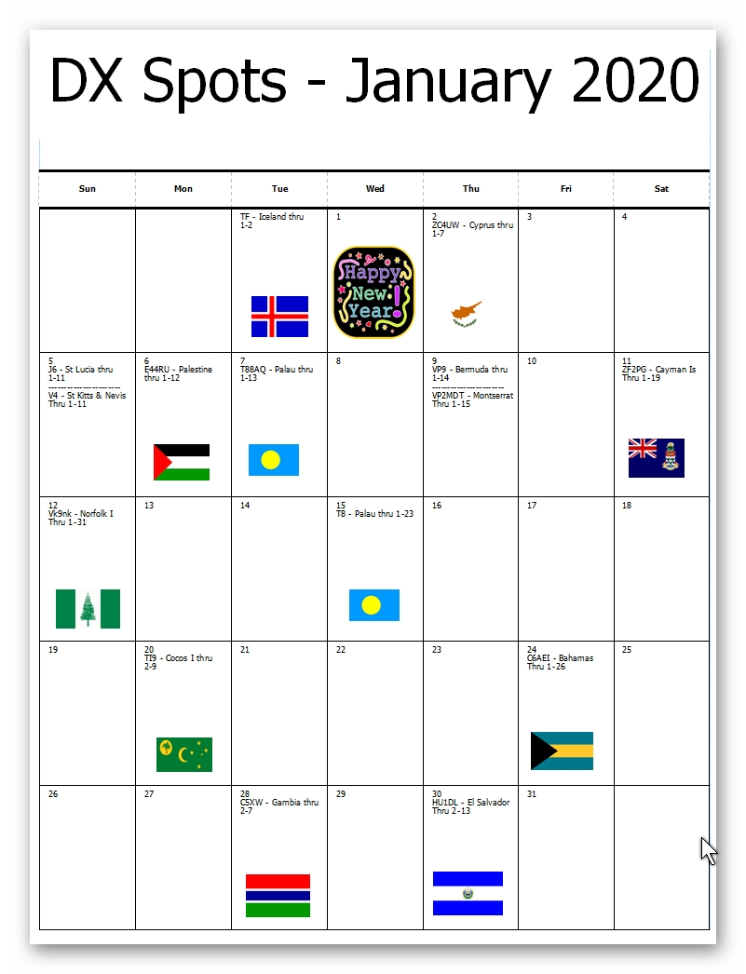
THE EXAM CORNER

By Steve Weeks, AA8SW

Continuous improvement in our knowledge and skills is a fundamental obligation of every radio amateur. So, it is natural that license class upgrades are an important part of the Ham Radio experience. Contrary to most of the time that the amateur radio service has been in existence, the FCC now only awards three license levels, so only two upgrades are possible: from Technician to General, and General to Extra Class. This presents a remarkable opportunity for Tech licensees, since it is now possible to gain dramatically increased privileges with only one upgrade. The General license is now the sweet spot – I estimate that it provides 90% of the rights that Extra Class Hams have, compared to perhaps 20% for Technicians. General Class opens up the traditional Ham Radio experience, with the opportunity to “work the world” and utilize almost the entire spectrum of modes and frequencies that are allocated to radio amateurs. You can disagree with my percentages, which are just my opinion, but it is beyond dispute that General licensees now get the vast majority of the maximum privileges given to Extra Class Hams. It is a great deal that every Tech should consider.

I maintain that almost anyone holding a Technician license can upgrade to General with a very reasonable amount of effort – far less effort than many believe. Why do I say that? Because the FCC has established rules that are so much in your favor:

1. The exam is multiple choice, with only four answers per question, and no penalty for guessing.
2. The passing score is only 74%. And you can re-take the exam as many times as necessary.
3. You only have to do it once in a lifetime – there are no continuing education or re-testing requirements.
4. And most importantly, they tell us all of the possible questions in advance!

Having access to the entire question pool in advance creates an amazing opportunity ‒ websites can create practice exams using the actual exam questions. With only a modest effort, you can review all of the possible questions so that when you go to take the real exam, you have already seen every question that will be presented.

Does this sound good? I hope so. But what you need is a road map, so you can review the question pool in an organized way and with a minimum of effort. For the OHKYIN General upgrade classes that Robert K4PKM and I taught last year, we developed course materials designed to do exactly that. Of course, we welcome all Techs to take our classes in 2020, and we will guide you through the materials (we review the entire question pool in 10 hours of class time). However, some people prefer a self-study approach. Maybe you are too busy to take an entire night for a class each week, or you are uncomfortable in a classroom situation, or you prefer a slower and less intense approach than weekly classes, or you don’t want to wait for the next class in the Spring.

Regardless of the reason, we want to help you too! So, we have uploaded the entire course materials to the OHKYIN website. There are 35 questions on the exam, and the pool contains an average of 12 questions which could be selected for each of the 35 questions on the real exam. The course materials consist of 35 pages, one for each exam question, in which we very briefly discuss the information which is needed to answer each of those 12 or so questions. Once again, with only one exception, we kept the information needed to answer each group of 12 or so questions down to one page, so it only takes a few minutes to review. After studying that one page, you can take an online practice test covering just those 12 or so questions, to really lock in your success. In addition to the OHKYIN course materials, you will need a copy of the question pool ‒ which you can also download for free from the website, or you can purchase a book like ARRL’s General Q&A, which we use in the OHKYIN classes.

Here is an example of how it works. This explanation appears in the course material:

Generally the allowed transmission power is 1500 watts PEP – but only the minimum power needed for the communication should be used. All power limits are based on peak envelope power (PEP). Once again, there are special exceptions for 30 and 60 meters:

30 meters – 200 watts PEP
60 meters – 100 watts PEP relative to a dipole (if antenna is other than a dipole, operator must maintain a record of antenna gain). Also, SSB signal width limited to 2.8 kHz.

Then we list the questions that are answered by that information. When you look them up, you find the following (with my comments, added just for this article, in bold):

G1C01 What is the maximum transmitting power an amateur station may use on 10.140 MHz?
A. 200 watts PEP output
B. 1000 watts PEP output
C. 1500 watts PEP output
D. 2000 watts PEP output
This is 30 meters, so the special 200-watt limit applies, and the answer is (A).

G1C02 What is the maximum transmitting power an amateur station may use on the 12-meter band?
A. 50 watts PEP output
B. 200 watts PEP output
C. 1500 watts PEP output
D. An effective radiated power equivalent to 100 watts from a half-wave dipole
No special limit applies to 12 meters, so the general 1500-watt limit applies, and the answer is (C),

G1C03 What is the maximum bandwidth permitted by FCC rules for Amateur Radio stations transmitting on USB frequencies in the 60-meter band?
A. 2.8 kHz
B. 5.6 kHz
C. 1.8 kHz
D. 3 kHz
The special 60-meter bandwidth limitation is 2.8 kHz, so the answer is (A).

G1C04 Which of the following limitations apply to transmitter power on every amateur band?
A. Only the minimum power necessary to carry out the desired communications should be used
B. Power must be limited to 200 watts when using data transmissions
C. Power should be limited as necessary to avoid interference to another radio service on the frequency
D. Effective radiated power cannot exceed 1500 watts
The answer is (A). That can also be determined by process of elimination since the other answers are obviously wrong ‒ which is often the case in this question pool. If you don’t know an answer on the real exam, eliminate as many wrong choices as possible and then guess since there is no penalty; never leave a question blank.

G1C05 What is the limit for transmitter power on the 28 MHz band for a General Class control operator?
A. 100 watts PEP output
B. 1000 watts PEP output
C. 1500 watts PEP output
D. 2000 watts PEP output
No special limit applies to 10 meters, so the general 1500-watt limit applies, and the answer is (C),

G1C06 What is the limit for transmitter power on the 1.8 MHz band?
A. 200 watts PEP output
B. 1000 watts PEP output
C. 1200 watts PEP output
D. 1500 watts PEP output
No special limit applies to 160 meters, so the general 1500-watt limit applies, and the answer is (D),

G1C12 Which of the following is required by the FCC rules when operating in the 60-meter band?
A. If you are using an antenna other than a dipole, you must keep a record of the gain of your antenna
B. You must keep a record of the date, time, frequency, power level, and stations worked
C. You must keep a record of all third-party traffic
D. You must keep a record of the manufacturer of your equipment and the antenna used
Answer (A) is a special requirement of 60 meters.

G1C14 What is the maximum power limit on the 60-meter band?
A. 1500 watts PEP
B. 10 watts RMS
C. ERP of 100 watts PEP with respect to a dipole
D. ERP of 100 watts PEP with respect to an isotropic antenna
Answer (C) is a special requirement of 60 meters.

G1C15 What measurement is specified by FCC rules that regulate maximum power output?
A. RMS
B. Average
C. Forward
D. PEP
All FCC limits are based on peak envelope power, answer (D).

I can assure you, from personal experience, that there is nothing like going into an exam session and realizing, I know that one, and that one, and that one, over and over, because I have seen them all before. Exam anxiety is banished! You can take online practice tests before the real thing so you will know when you are ready and be confident. Remember, the passing score is only 74% so you can miss 9 out of 35 questions and still pass. You can do this!

Robert and I hope that all Techs will consider upgrading, either through OHKYIN classes or self-study, and we are happy to help in any way that we can. Please contact me at AA8SW@att.net or at a club meeting if you have any questions.

January 2020 Brunch Bunch
The next Brunch Bunch will be held Saturday, January 11th, at 1pm.
The location for January is: Sorrento’s Italian Joint 5143 Montgomery Road in Norwood, 45212.

Sorrento’s is located on Montgomery Road between Lawn Avenue and Sherwood Lane. There is parking available next to the building, as well as on the street.

“Sorrento’s Italian Joint is a labor of love for all to experience. Our family promises you the best in food, service and atmosphere. Whether it's a carryout, lunch...or a relaxing evening to hang out with us...we will deliver a unique Italian experience for you, your family, and your friends.”
For a look at the menu go to: www.sorrentosnorwood.com

Remember the Brunch Bunch always meets the second Saturday of every month at 1pm at a location to be announced each month. If you are not available to join us this month, maybe you'll be available to join us in the months ahead! I'm always looking for suggestions on what restaurant you think might be a good place to visit in the future. 73, Bruce N8BV

Harold W4YWH SK
Harold, W4YWH became a silent key on December 27th, 2019. To say Harold will be missed is a great understatement as he was a powerful, popular, and incredibly influential voice in the amateur radio community.

Many of us have stories of how Harold helped us, encouraged us, taught us in amateur radio operation and repair. While I did not know Harold as long as many of you reading this, Harold was one of the first Elmers I had in the hobby, and I always enjoyed talking with him on his repeater.

One of the first (of many to come, I am sure) comments on the reflector made about Harold, comes from Marty KE8CEI:
- As a fairly new Ham I still know who Harold Blocker is! He was a good man and a great amateur radio promoter. He will be missed.

For those who would like to pay their respects, visitation will be held:

Saturday, January 4, 2020 11AM – Noon
Muehlenkamp-Erschell Funeral Home
427 S Ft Thomas Ave, Fort Thomas, KY 41075
(Across the street from St Thomas Church)

  - “Elmers, the Unsung Fathers of Amateur Radio”
“The term Elmer first appeared in the March 1971 issue of QST magazine. In that issue, Rod Newkirk, W9BRD, called them “the unsung fathers of Amateur Radio.” He wrote that an Elmer is “the ham who took the most time and trouble to give you a push toward your license.”
“Where do you find an Elmer? Well, the first place you might look is the club you just joined. Lots of the “old timers” there are more than happy to help newcomers, and many clubs have “Elmer” programs. Ask for help and ye just may receive.
“Nowadays, you might find your Elmer online. There are lots of websites and mailing lists that are geared towards helping people become better amateur radio operators. You probably can get by without an Elmer, but without one, it’s easy to become frustrated and set aside the hobby.

“One ham I spoke with said, “I did not have an Elmer. I got my license, and within a year, I started a 20-year hiatus. I blame that on not having an Elmer.”
“You don’t want that to happen to you. Find an Elmer and take his or her advice. You’ll get a lot more out of the hobby.” Dan KB6NU

Technically Speaking
Gary Coffey KB8MYC, Technical Coordinator

With the New Year beginning I wanted to give everyone a quick update on our club repeaters. 2019 was very challenging with regard to our repeaters. Everyone is aware of the critical cable issue we have at the 146.670 site, hopefully that will be resolved soon. Here is a quick update of our equipment:
146.670 - As everyone knows, we have a major project underway to replace the hardline going up the tower. This project will cost the club in excess of $10,000 to complete. Money from our treasury has been allocated for the repairs and hopefully they will be completed by spring. We are currently awaiting word on when we can proceed from the tower owner, WLWT. In the meantime, the machine is usable, just with reduced coverage and sensitivity.
146.925 - This repeater, location Delhi Fire Station 36, is operating normally. It is running 20 watts and give good coverage in the Delhi / Green Twp. area. It is operating in dual mode, meaning you can use analog FM or Yaesu System Fusion.
146.625 - This machine is located at St. Elizabeth Hospital in Edgewood, Kentucky. This repeater has been off the air due to equipment issues. By the time you read this it should be back on the air. It is running 100 watts and is also in the dual FM / Fusion mode.
446.7625 - Temporarily off the air.
Our repeaters are one of our club’s greatest assets and our largest investments. We encourage you to use them. If you have questions about or repeaters or setting up your radio feel free to reach out to me.

Q-Fiver Editor: Robert Gulley (K4PKM) E-mail: ak3q@ak3q.com
For questions/comments/suggestions, or article submissions, send me an E-mail!

Another easy Way to help out the club: Your Kroger Card!
Link and use your Kroger Card - Earn money for OH-KY-IN!!
Do you have a Kroger rewards card? If so, the OH-KY-IN Amateur Radio Society has enrolled in the Kroger Community Rewards Program. If you link your card to OH-KY-IN, all eligible purchases you make using your Kroger card will generate income from the rewards program to OH-KY-IN.
OH-KY-IN has been assigned a Non-Profit Organization number of QY352.
To Use the Kroger Community Rewards Program:
You need to visit http://www.krogercommunityrewards.com Once logged into your Kroger account you can search for OH-KY-IN Amateur Radio Society either by name or QY352 and then click Enroll.
On the right side of this page is View by Type. Be sure to change this to ALL or to CIVIC ORGANIZATION before entering OH-KY-IN Amateur Radio Society or QY352. New users will need to create an account which requires some basic information, a valid email address and a rewards card number.
Customers must have a registered Kroger rewards card account to link it to OH-KY-IN.
If you do not yet have a Kroger rewards card, they are available at the customer service desk at any Kroger.
You must swipe your registered Kroger rewards card or use the phone number that is related to your registered Kroger rewards card when shopping for each purchase to count.
REMEMBER, your purchases will not count for your organization until after you register your rewards card.
Tell your friends about this too. Anyone with a Kroger card can link it to OH-KY-IN.
The OH-KY-IN Amateur Radio Society thanks you for taking just a few moments to link your card to your club!
73, Bruce N8BV

December 2019 General Meeting Minutes
Dec 3rd, 2019
Guests – Tom Delaney W8WTD
New license\Upgrades – None
47 in attendance
Brags
- Cesi KD8OOB, construction on house done, has station up
- Kitty W8TDA – participated in CW sweeps, managed to work 74 of 83 sections in 6-7 hours; however, she missed the deadline to turn in the log
- Robert K4PKM set up a 1.2GHz antenna
Meeting break for Christmas dinner 7:45pm
Meeting continued 8:15 pm
Ryan Owens presented award to the club from the CF bike ride organization.
Corrections to minutes as published
- Motion to accept and approved.
Tech Committee: 67 repeater coaxial issues; 625 is temporally off the air
George N3VQW needs backup net control on 25th
Field Day – we keep doing better every year.
Sweeps went well, couldn’t get BC or ND
Upcoming events:
- Winter Field Day 25th - 26 at Harvest Home Park
- Feb 23rd (ish), ARISS School event
- June 2020, Region 2 Youth on the Air. It is being actively promoted. Yotaregion2.org
- ARDF style 2 Meter foxhunt will be at Harbin park, Dec 14th, week from Saturday
Tech Talk net will be held on the QCEN 147.24 repeater until further notice (when the controller is returned to service)
New Business
Election: Fred - motion to vote slate of officers; Ted second, all approved unanimously.

No board meeting in Dec, informal get-together instead
January, we will have a new Q-Fiver editor in January
Awards:
- Meritorious Service Award - Gary Coffey KB8MYC
- Meritorious Service Award - George N3VQW
- Ham of the Year - Steve Weeks AA8SW
Split the pot: K4PKM Robert won $122
Door Prizes and Winners:
- Kenwood compatible speaker mic: KD8ILQ
- Multimeter: K4PKM
- Get on the air with HF Digital book: WA6EZV
- Small Antennas for Small Spaces book: Cesi KD8OOB, Mike KG4DSG, John KD8MMY
- Portable Antenna Classics book: KE4AV, K8EAF, W8TDA, KD8SOH, WA6EZV
- 2019 ARRL Handbook: K4PKM
- RTS Systems Baofeng Programming manual, Jan 1942 QST magazine: KD8DZS
- Speaker Mic Baofeng: K8EAF
- Baofeng UV5R: KG8AP, KE8COY JUSTIN
- Baofeng UV5R: Tri-bander w/ programming cable - KD8OOB, AC8UJ
- Yaesu FT4x dual band handheld: KD8ZLB, K9OHE
- Yaesu FTM7250D: N3VQW
QCEN Meeting\Christmas Dinner on the 13th
12th day of Christmas on the 14th
-- Submitted by George N3VQW

OH-KY-IN Amateur Radio Society is one of the leading amateur radio organizations in the Cincinnati, Ohio area and has been for most of its 50-plus year history. We are a 501(c)(3) nonprofit organization dedicated to the advancement of all things radio. No matter the amateur radio interest, OH-KY-IN members are involved.

